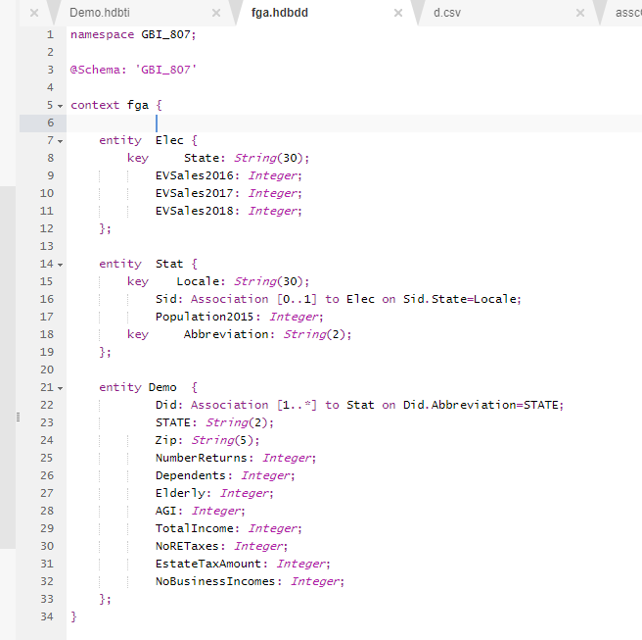

/* CreateCDS HDTable- file: fga.hdbdd */

/* Associations and keys are not necessary for import and for tables to join */

/* On import, primary key (X1) set- State for .Elec, Local for .Stat, STATE for Demo */

/* on hdbti import, tables created with populated data for .Elec and .Stat */

/* .Demo showed duplicate row error, so key dropped from STATE-table imports */

**namespace GBI_807;**

**@Schema: 'GBI_807'**

**context fga {**

**entity Elec {**

**key State: String(30);**

**EVSales2016: Integer;**

**EVSales2017: Integer;**

**EVSales2018: Integer;**

**};**

**entity Stat {**

**key Locale: String(30);**

**Sid: Association [0..1] to Elec on Sid.State=Locale;**

**Population2015: Integer;**

**key Abbreviation: String(2);**

**};**

**entity Demo {**

**Did: Association [1..*] to Stat on Did.Abbreviation=STATE;**

**STATE: String(2);**

**Zip: String(5);**

**NumberReturns: Integer;**

**Dependents: Integer;**

**Elderly: Integer;**

**AGI: Integer;**

**TotalIncome: Integer;**

**NoRETaxes: Integer;**

**EstateTaxAmount: Integer;**

**NoBusinessIncomes: Integer;**

**};**

**}**

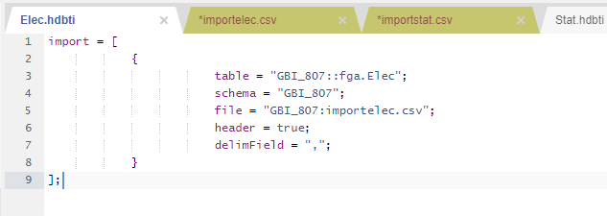

**import = [**

**{**

**table = "GBI_807::fga.Elec";**

**schema = "GBI_807";**

**file = "GBI_807:importelec.csv";**

**header = true;**

**delimField = ",";**

**}**

**];**

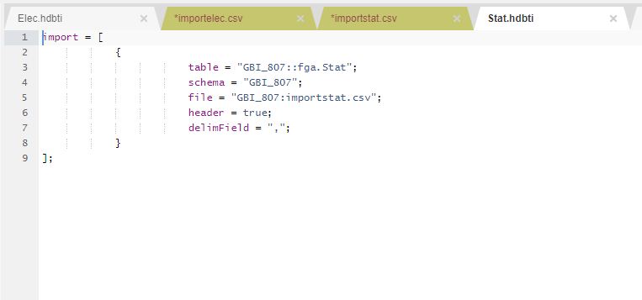

**import = [**

**{**

**table = "GBI_807::fga.Stat";**

**schema = "GBI_807";**

**file = "GBI_807:importstat.csv";**

**header = true;**

**delimField = ",";**

**}**

**];**

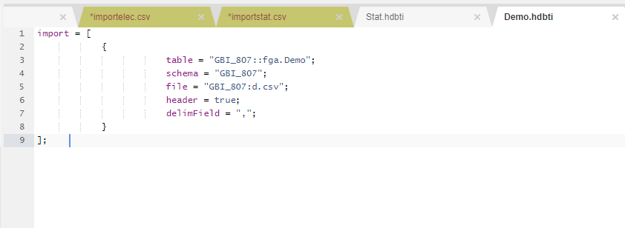

**import = [**

**{**

**table = "GBI_807::fga.Demo";**

**schema = "GBI_807";**

**file = "GBI_807:d.csv";**

**header = true;**

**delimField = ",";**

**}**

**];**

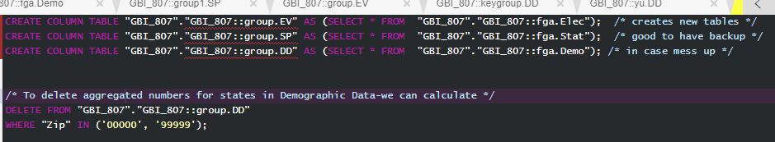

CREATE COLUMN TABLE "GBI_807"."GBI_807::group.EV" AS (SELECT * FROM "GBI_807"."GBI_807::fga.Elec"); /* creates new tables */

CREATE COLUMN TABLE "GBI_807"."GBI_807::group.SP" AS (SELECT * FROM "GBI_807"."GBI_807::fga.Stat"); /* good to have backup */

CREATE COLUMN TABLE "GBI_807"."GBI_807::group.DD" AS (SELECT * FROM "GBI_807"."GBI_807::fga.Demo"); /* in case mess up */

/* To delete aggregated numbers for states in Demographic Data-we can calculate */

DELETE FROM "GBI_807"."GBI_807::group.DD"

WHERE "Zip" IN ('00000', '99999');

**/* 1. List the top 10 states by total electric vehicle sales (descending order) */**

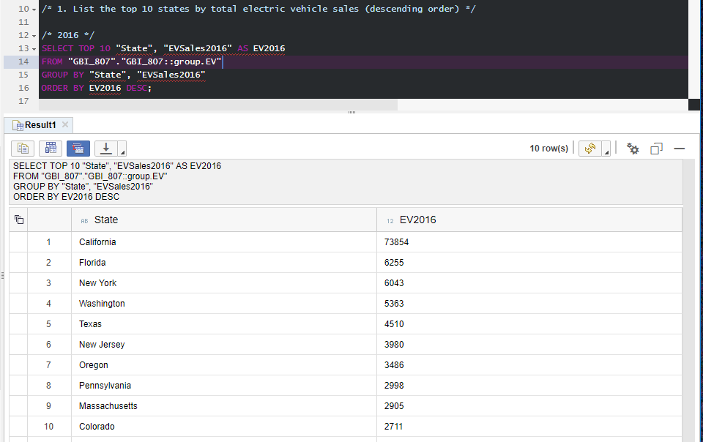

/* 2016 */

SELECT TOP 10 "State", "EVSales2016" AS EV2016

FROM "GBI_807"."GBI_807::group.EV"

GROUP BY "State", "EVSales2016"

ORDER BY EV2016 DESC;

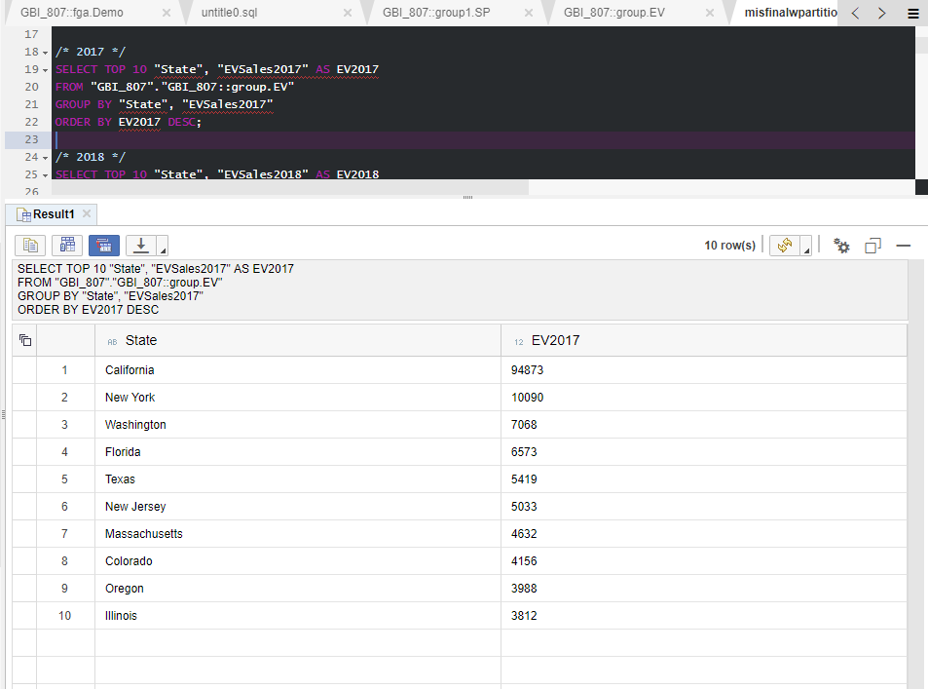

/* 2017 */

SELECT TOP 10 "State", "EVSales2017" AS EV2017

FROM "GBI_807"."GBI_807::group.EV"

GROUP BY "State", "EVSales2017"

ORDER BY EV2017 DESC;

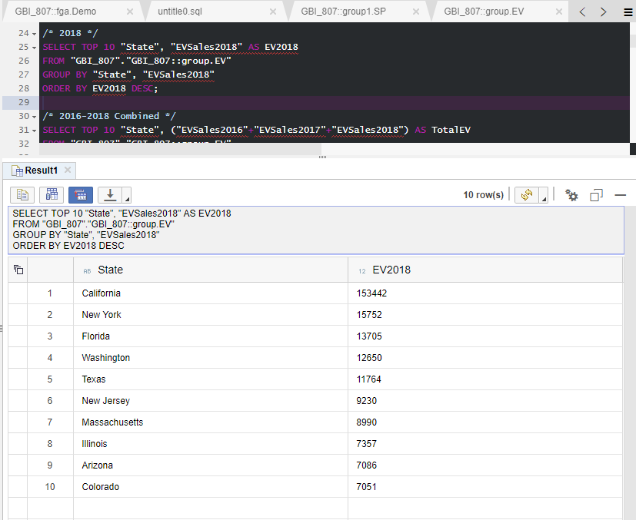

/* 2018 */

SELECT TOP 10 "State", "EVSales2018" AS EV2018

FROM "GBI_807"."GBI_807::group.EV"

GROUP BY "State", "EVSales2018"

ORDER BY EV2018 DESC;

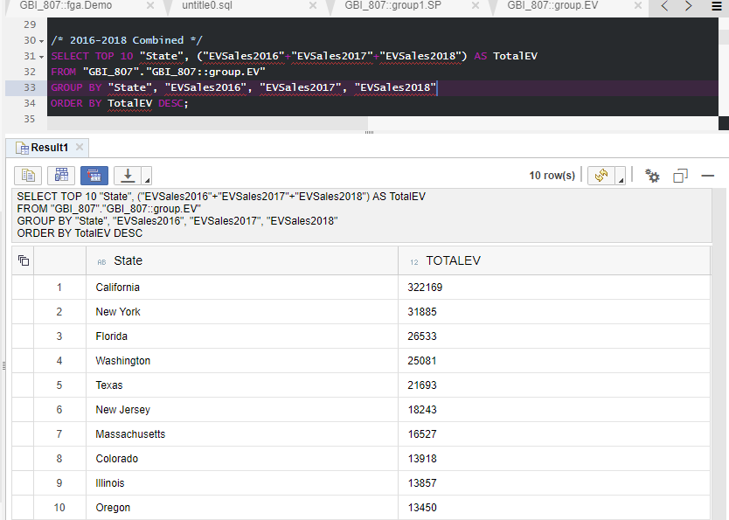

/* 2016-2018 Combined */

SELECT TOP 10 "State", ("EVSales2016"+"EVSales2017"+"EVSales2018") AS TotalEV

FROM "GBI_807"."GBI_807::group.EV"

GROUP BY "State", "EVSales2016", "EVSales2017", "EVSales2018"

ORDER BY TotalEV DESC;

**/* 2. List the top 10 states by number of electric vehicle sales per capita (descending order) */**

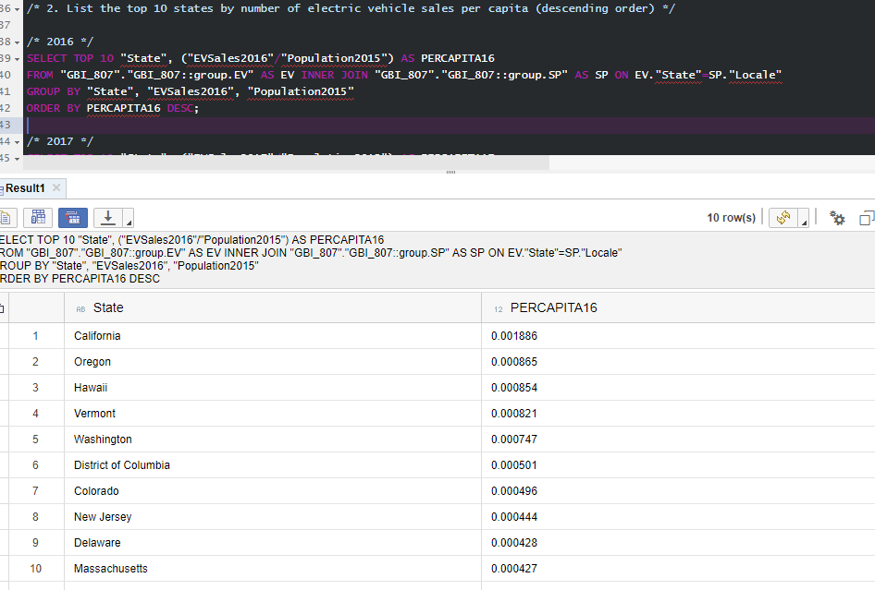

/* 2016 */

SELECT TOP 10 "State", ("EVSales2016"/"Population2015") AS PERCAPITA16

FROM "GBI_807"."GBI_807::group.EV" AS EV INNER JOIN "GBI_807"."GBI_807::group.SP" AS SP ON EV."State"=SP."Locale"

GROUP BY "State", "EVSales2016", "Population2015"

ORDER BY PERCAPITA16 DESC;

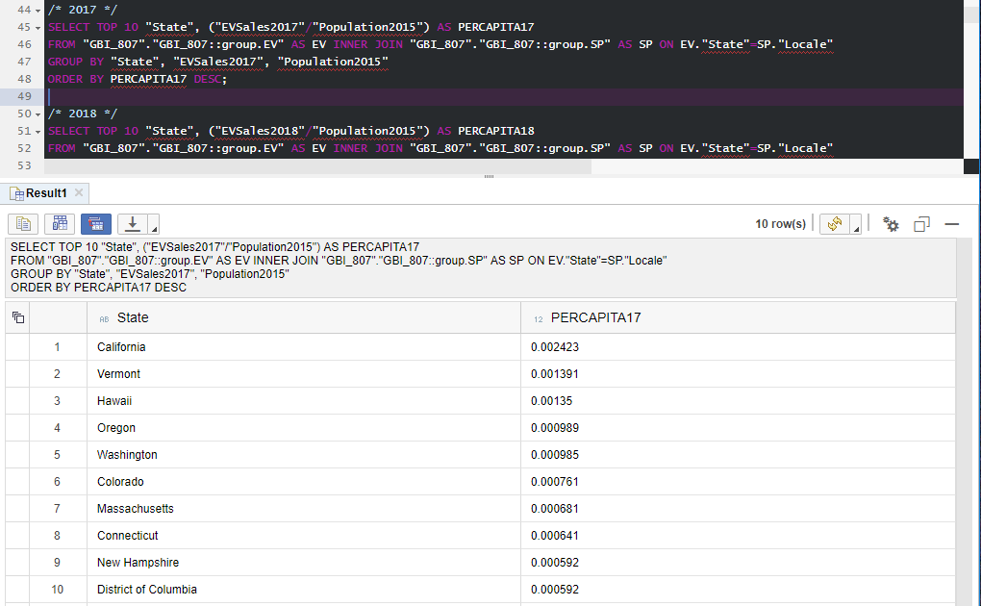

/* 2017 */

SELECT TOP 10 "State", ("EVSales2017"/"Population2015") AS PERCAPITA17

FROM "GBI_807"."GBI_807::group.EV" AS EV INNER JOIN "GBI_807"."GBI_807::group.SP" AS SP ON EV."State"=SP."Locale"

GROUP BY "State", "EVSales2017", "Population2015"

ORDER BY PERCAPITA17 DESC;

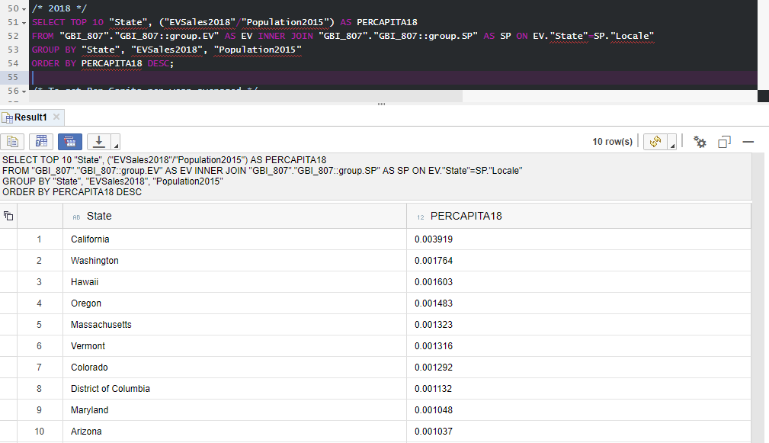

/* 2018 */

SELECT TOP 10 "State", ("EVSales2018"/"Population2015") AS PERCAPITA18

FROM "GBI_807"."GBI_807::group.EV" AS EV INNER JOIN "GBI_807"."GBI_807::group.SP" AS SP ON EV."State"=SP."Locale"

GROUP BY "State", "EVSales2018", "Population2015"

ORDER BY PERCAPITA18 DESC;

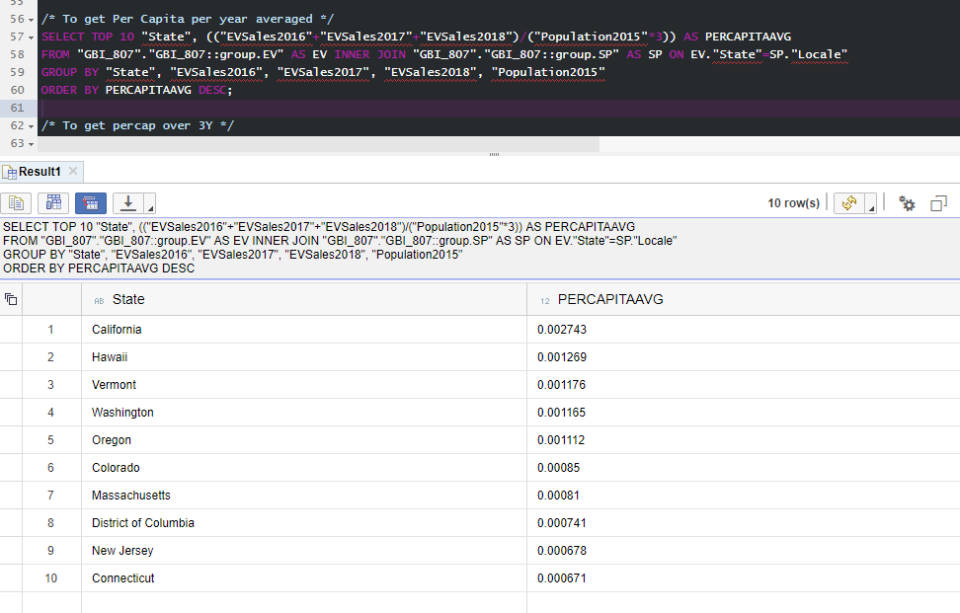

/* To get Per Capita per year averaged */

SELECT TOP 10 "State", (("EVSales2016"+"EVSales2017"+"EVSales2018")/("Population2015"*3)) AS PERCAPITAAVG

FROM "GBI_807"."GBI_807::group.EV" AS EV INNER JOIN "GBI_807"."GBI_807::group.SP" AS SP ON EV."State"=SP."Locale"

GROUP BY "State", "EVSales2016", "EVSales2017", "EVSales2018", "Population2015"

ORDER BY PERCAPITAAVG DESC;

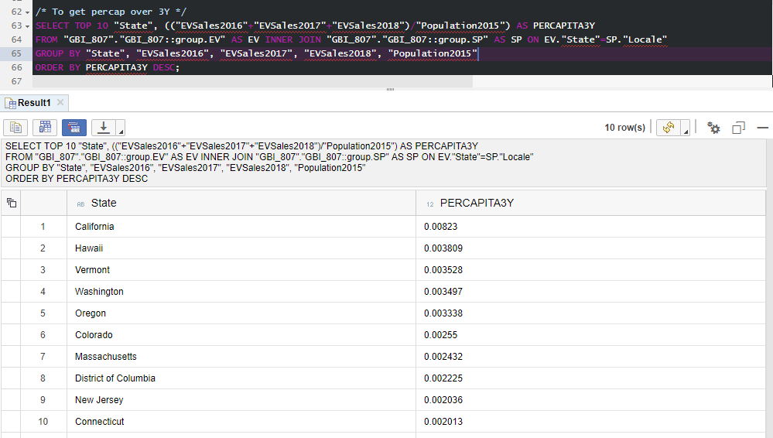

/* To get percap over 3Y */

SELECT TOP 10 "State", (("EVSales2016"+"EVSales2017"+"EVSales2018")/"Population2015") AS PERCAPITA3Y

FROM "GBI_807"."GBI_807::group.EV" AS EV INNER JOIN "GBI_807"."GBI_807::group.SP" AS SP ON EV."State"=SP."Locale"

GROUP BY "State", "EVSales2016", "EVSales2017", "EVSales2018", "Population2015"

ORDER BY PERCAPITA3Y DESC;

**/* 3. List for states beginning with 'A', the zip codes with total incomes greater than the average for the state */**

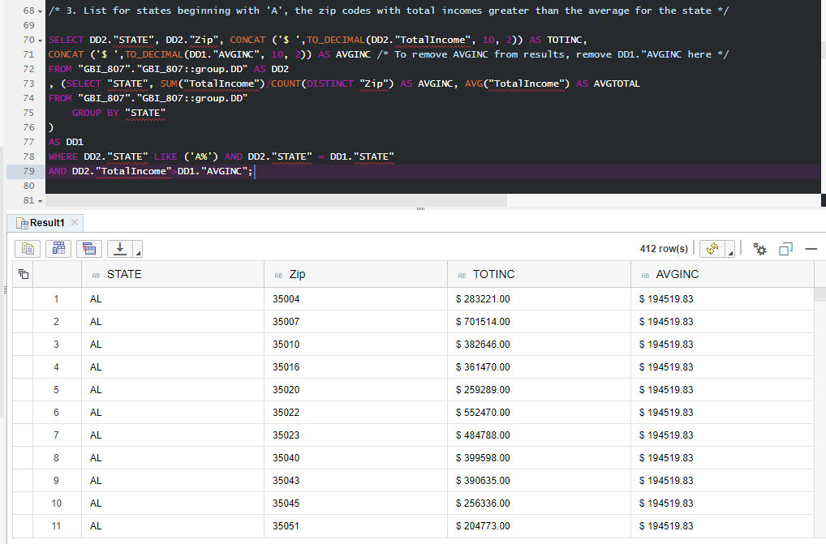

SELECT DD2."STATE", DD2."Zip", CONCAT ('$ ',TO_DECIMAL(DD2."TotalIncome", 10, 2)) AS TOTINC,

CONCAT ('$ ',TO_DECIMAL(DD1."AVGINC", 10, 2)) AS AVGINC /* To remove AVGINC from results, remove DD1."AVGINC here */

FROM "GBI_807"."GBI_807::group.DD" AS DD2

, (SELECT "STATE", SUM("TotalIncome")/COUNT(DISTINCT "Zip") AS AVGINC, AVG("TotalIncome") AS AVGTOTAL

FROM "GBI_807"."GBI_807::group.DD"

GROUP BY "STATE"

)

AS DD1

WHERE DD2."STATE" LIKE ('A%') AND DD2."STATE" = DD1."STATE"

AND DD2."TotalIncome">DD1."AVGINC";

/* SEE ADDENDUM FOR ALL 412 Rows */

**/* 4. List for each state, the top zip code by AGI? */**

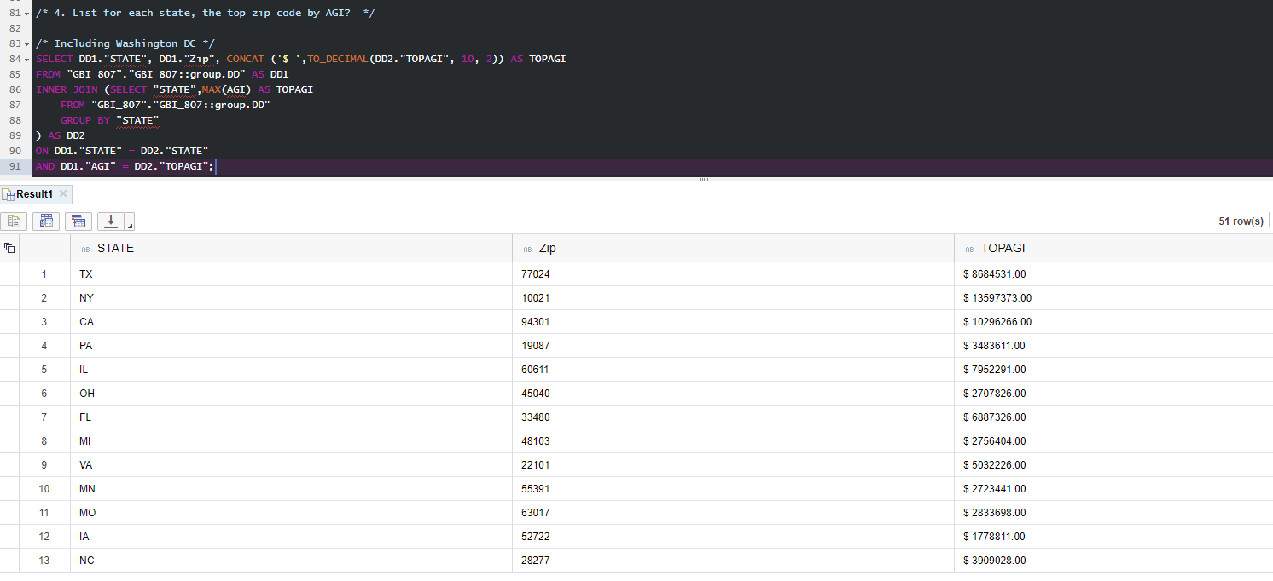

/* Including Washington DC */

SELECT DD1."STATE", DD1."Zip", CONCAT ('$ ',TO_DECIMAL(DD2."TOPAGI", 10, 2)) AS TOPAGI

FROM "GBI_807"."GBI_807::group.DD" AS DD1

INNER JOIN (SELECT "STATE",MAX(AGI) AS TOPAGI

FROM "GBI_807"."GBI_807::group.DD"

GROUP BY "STATE"

) AS DD2

ON DD1."STATE" = DD2."STATE"

AND DD1."AGI" = DD2."TOPAGI";

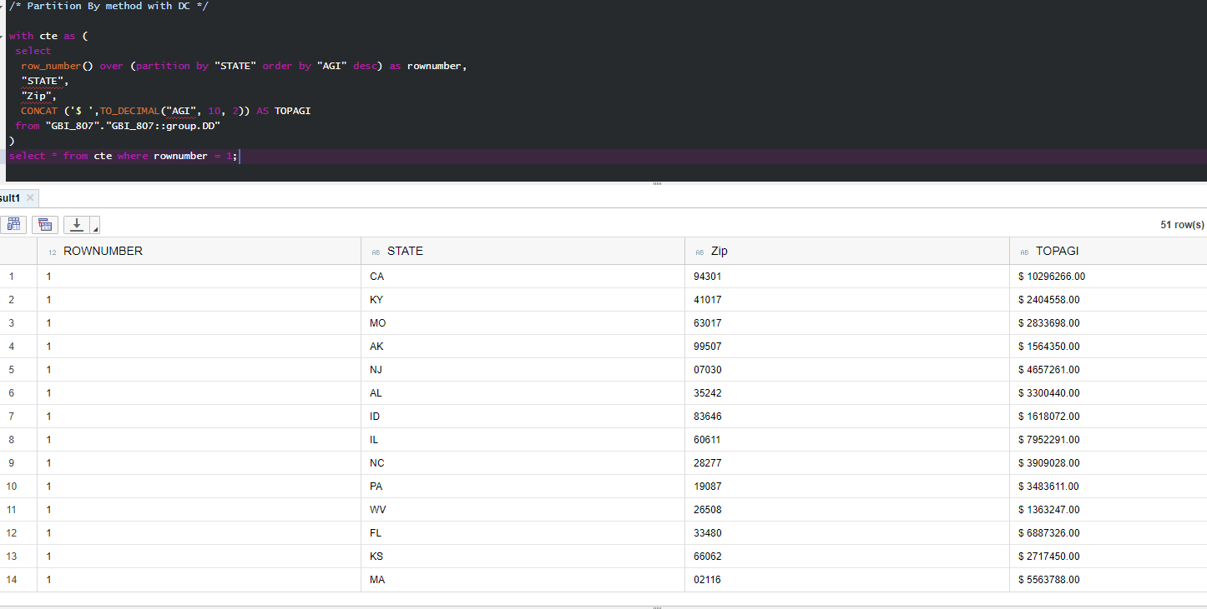

/* Partition By method with DC */

with cte as (

select

row_number() over (partition by "STATE" order by "AGI" desc) as rownumber,

"STATE",

"Zip",

CONCAT ('$ ',TO_DECIMAL("AGI", 10, 2)) AS TOPAGI

from "GBI_807"."GBI_807::group.DD"

)

select * from cte where rownumber = 1;

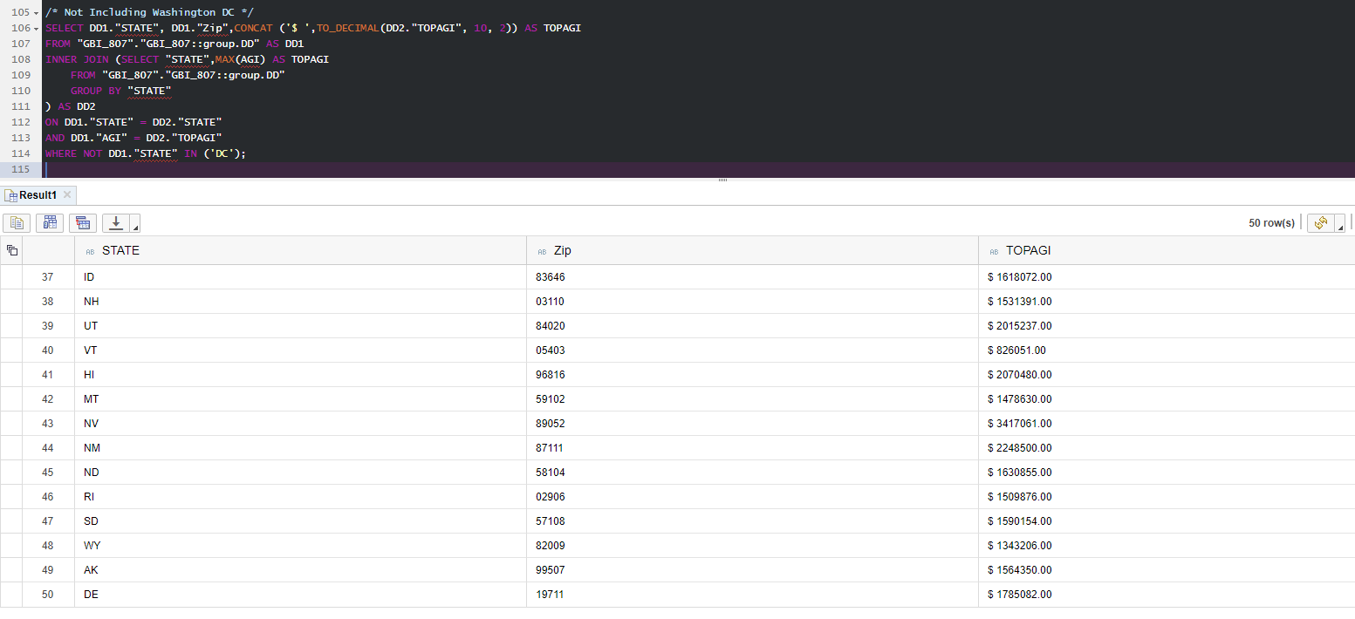

/* Not Including Washington DC */

SELECT DD1."STATE", DD1."Zip",CONCAT ('$ ',TO_DECIMAL(DD2."TOPAGI", 10, 2)) AS TOPAGI

FROM "GBI_807"."GBI_807::group.DD" AS DD1

INNER JOIN (SELECT "STATE",MAX(AGI) AS TOPAGI

FROM "GBI_807"."GBI_807::group.DD"

GROUP BY "STATE"

) AS DD2

ON DD1."STATE" = DD2."STATE"

AND DD1."AGI" = DD2."TOPAGI"

WHERE NOT DD1."STATE" IN ('DC');

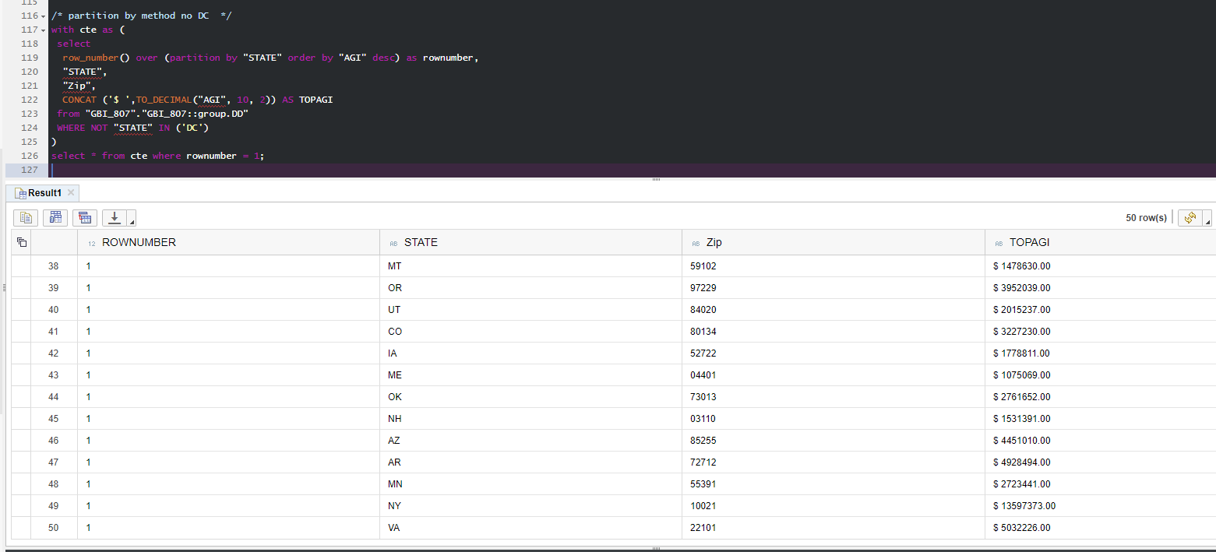

/* partition by method no DC */

with cte as (

select

row_number() over (partition by "STATE" order by "AGI" desc) as rownumber,

"STATE",

"Zip",

CONCAT ('$ ',TO_DECIMAL("AGI", 10, 2)) AS TOPAGI

from "GBI_807"."GBI_807::group.DD"

WHERE NOT "STATE" IN ('DC')

)

select * from cte where rownumber = 1;

/* SEE ADDENDUM FOR FULL 50+51 ZIP Code RESULTS */

**/* 5. List the top 5 states by number of returns per capita (descending order) */**

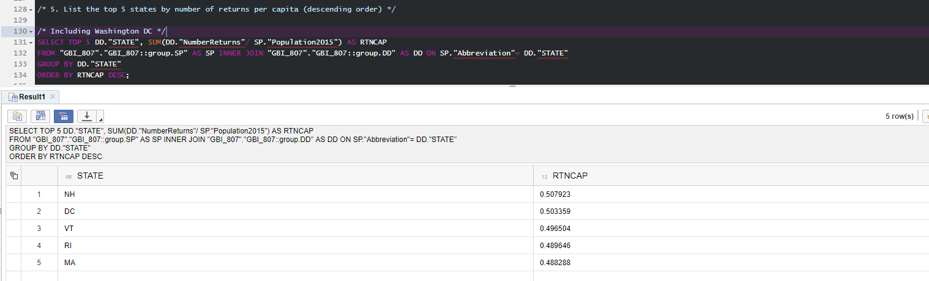

/* Including Washington DC */

SELECT TOP 5 DD."STATE", SUM(DD."NumberReturns"/ SP."Population2015") AS RTNCAP

FROM "GBI_807"."GBI_807::group.SP" AS SP INNER JOIN "GBI_807"."GBI_807::group.DD" AS DD ON SP."Abbreviation"= DD."STATE"

GROUP BY DD."STATE"

ORDER BY RTNCAP DESC;

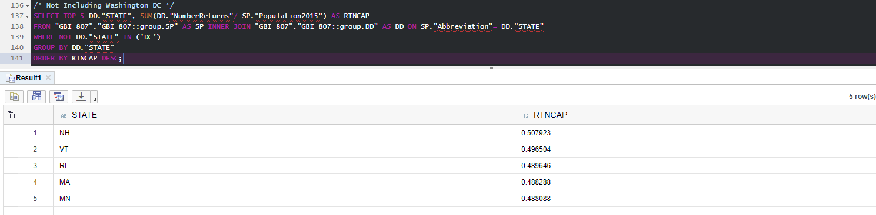

/* Not Including Washington DC */

SELECT TOP 5 DD."STATE", SUM(DD."NumberReturns"/ SP."Population2015") AS RTNCAP

FROM "GBI_807"."GBI_807::group.SP" AS SP INNER JOIN "GBI_807"."GBI_807::group.DD" AS DD ON SP."Abbreviation"= DD."STATE"

WHERE NOT DD."STATE" IN ('DC')

GROUP BY DD."STATE"

ORDER BY RTNCAP DESC;

**1. Which states have the most electric vehicle sales (total and over time)?**

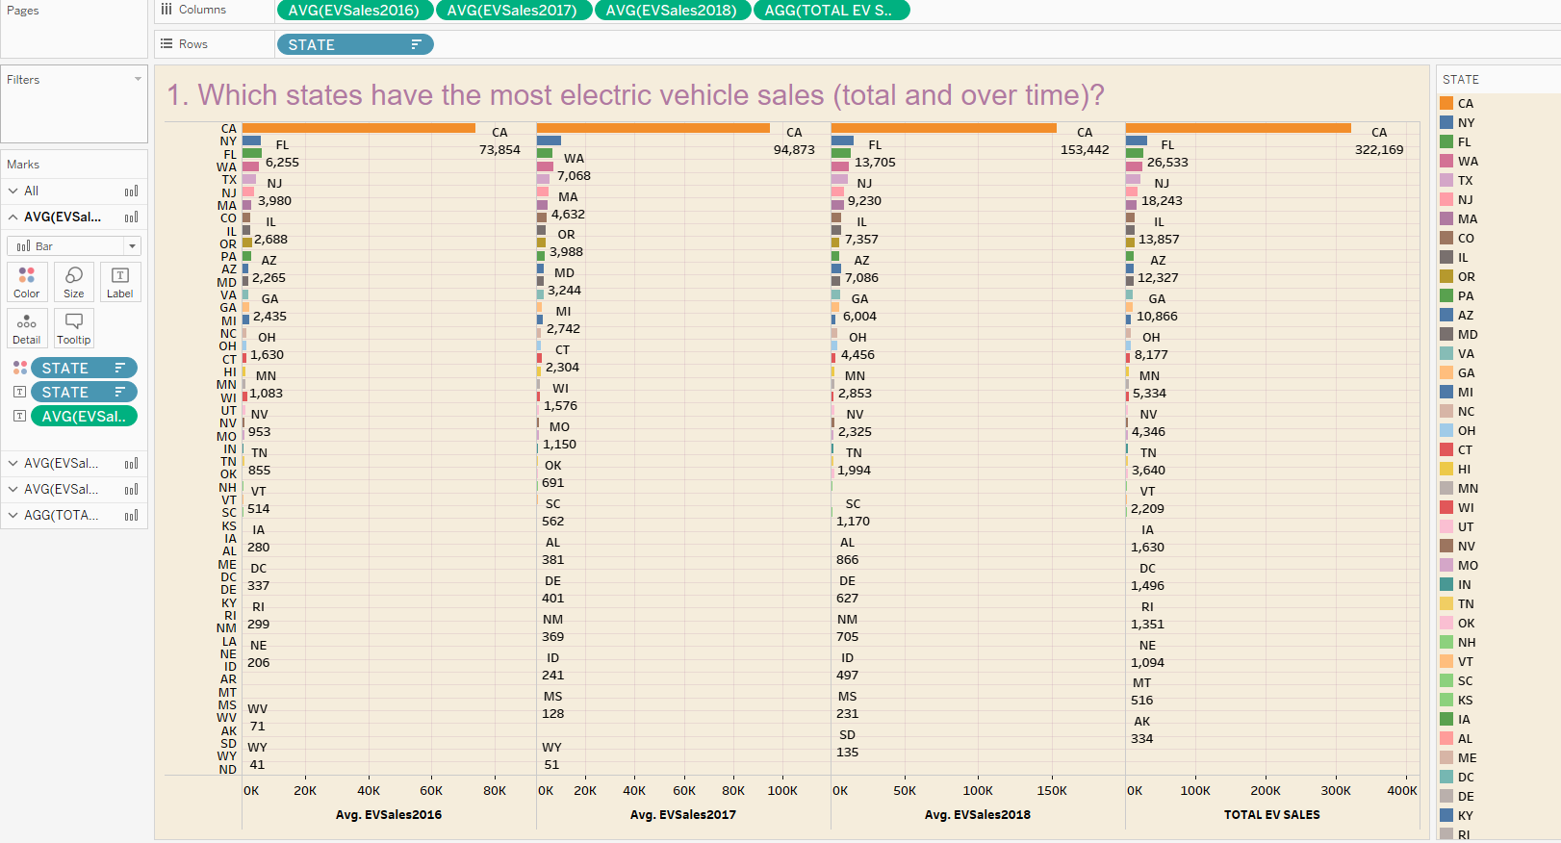

**2. How would electric vehicle sales totals look on a map of states?**

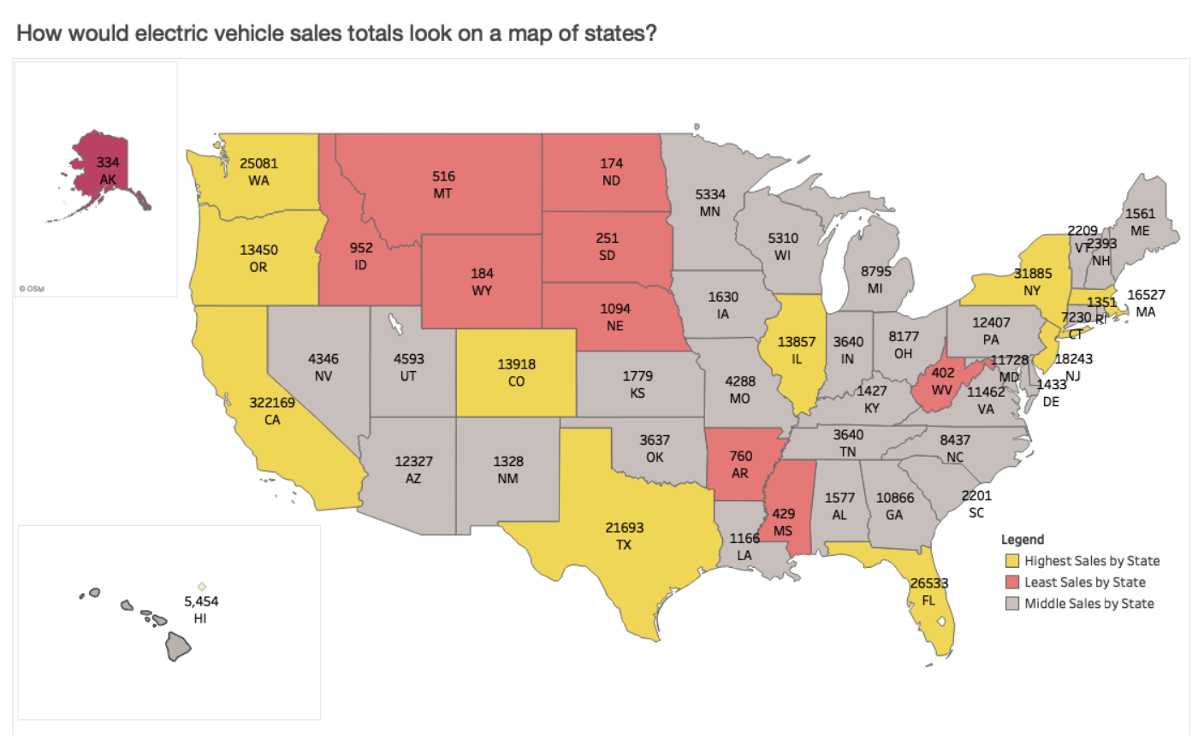

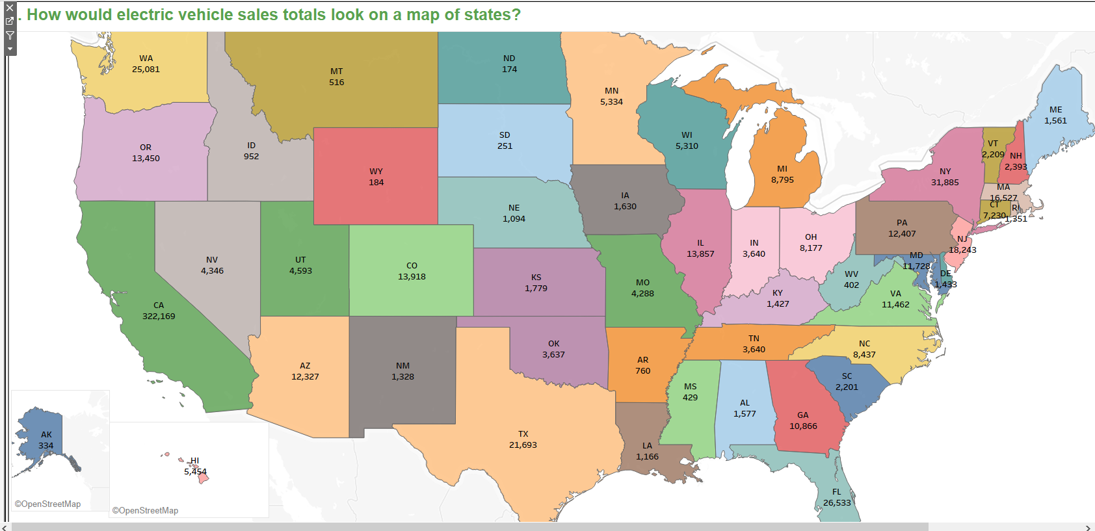

**3. Which states have the most electric vehicle sales per capita (total and over time)?**

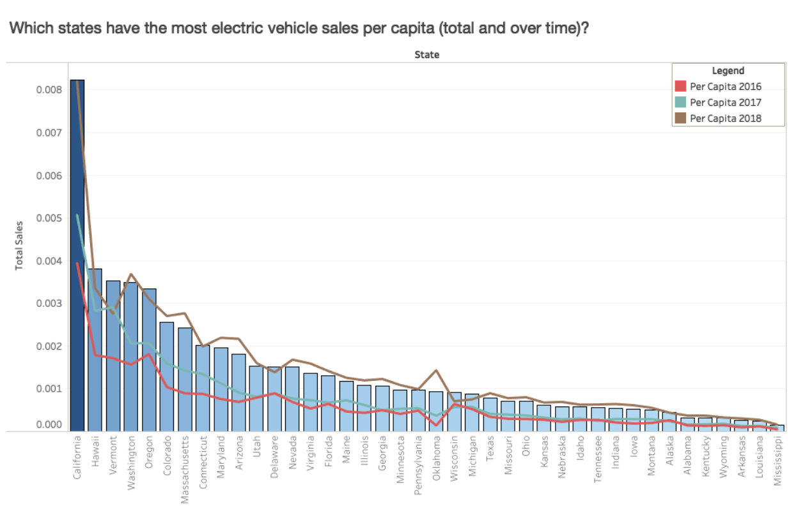

**4. Show car sales over 3 years for 10 states that have the highest median AGI**

**With DC**

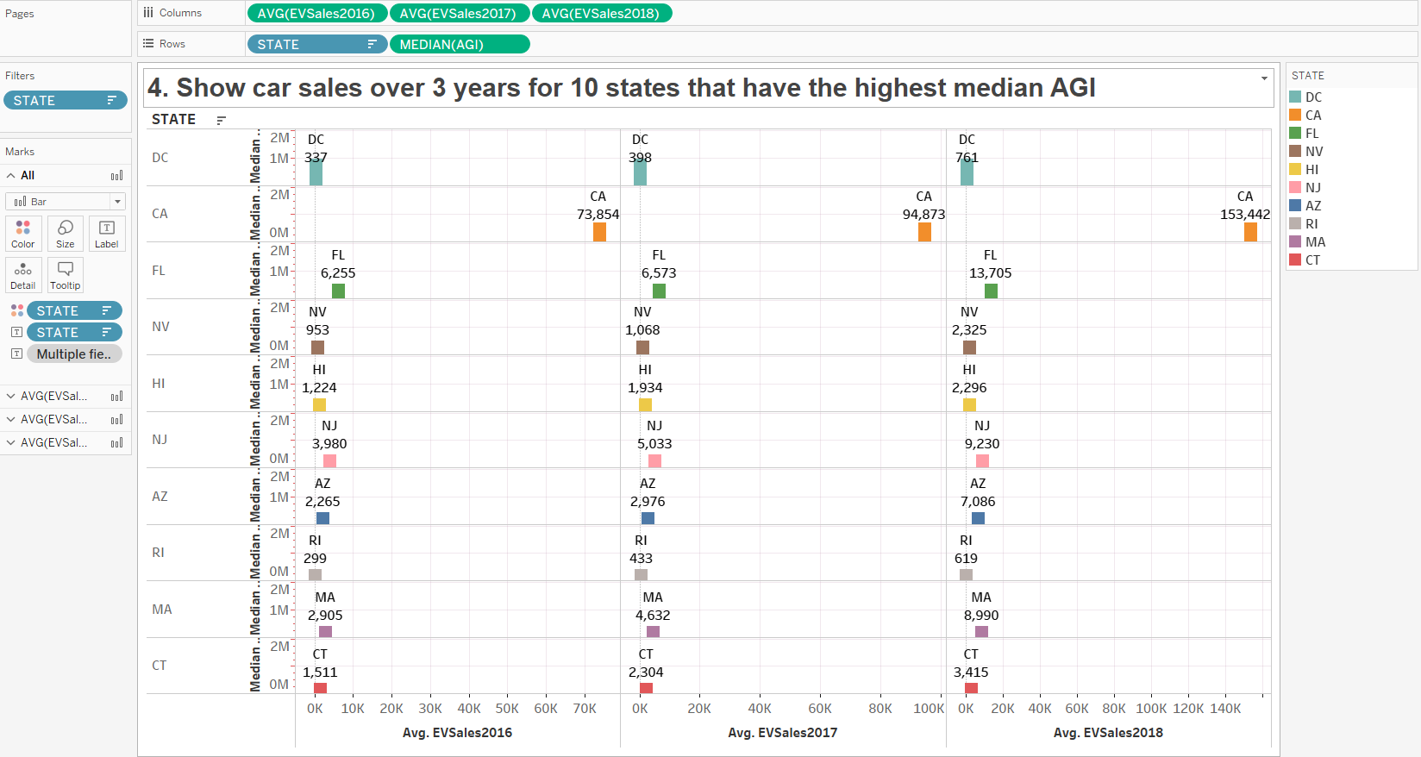

Without DC

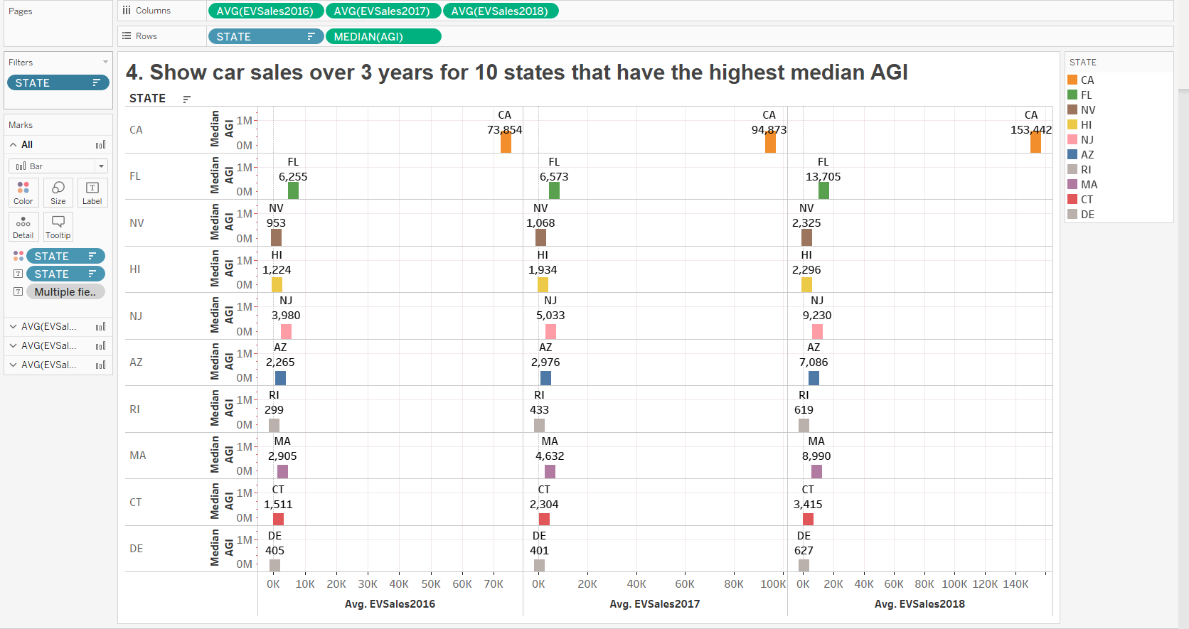

**5. Are there any significant relationships between state electric vehicle sales, state populations and average state incomes?**

**This part shows taking the AVG of Total Income for each state versus the SUM of Total Income for each state divided by the Number of returns for each state (as discuss in email)**

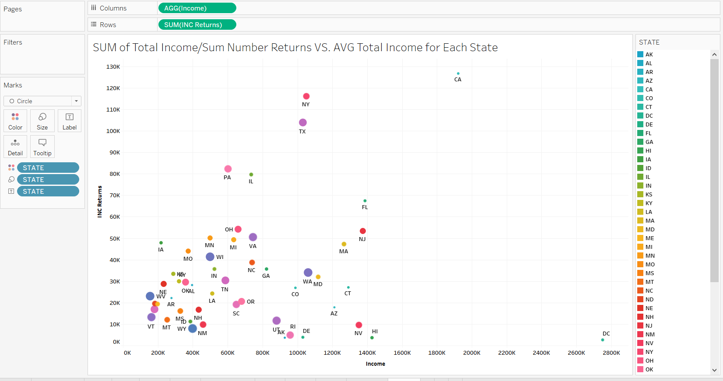

**This shows relationships between Total EV Sales vs. Average State Income vs State Populations**

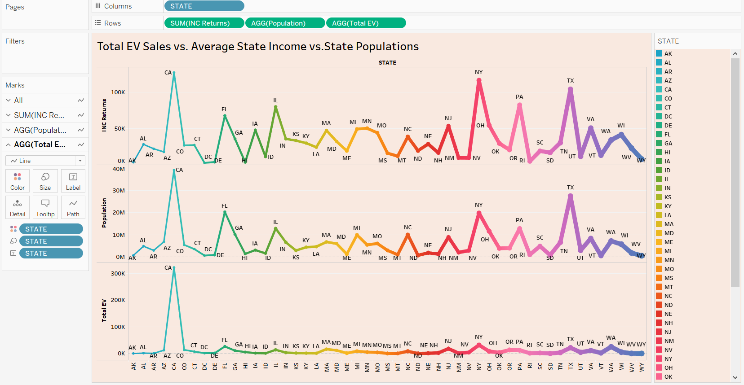

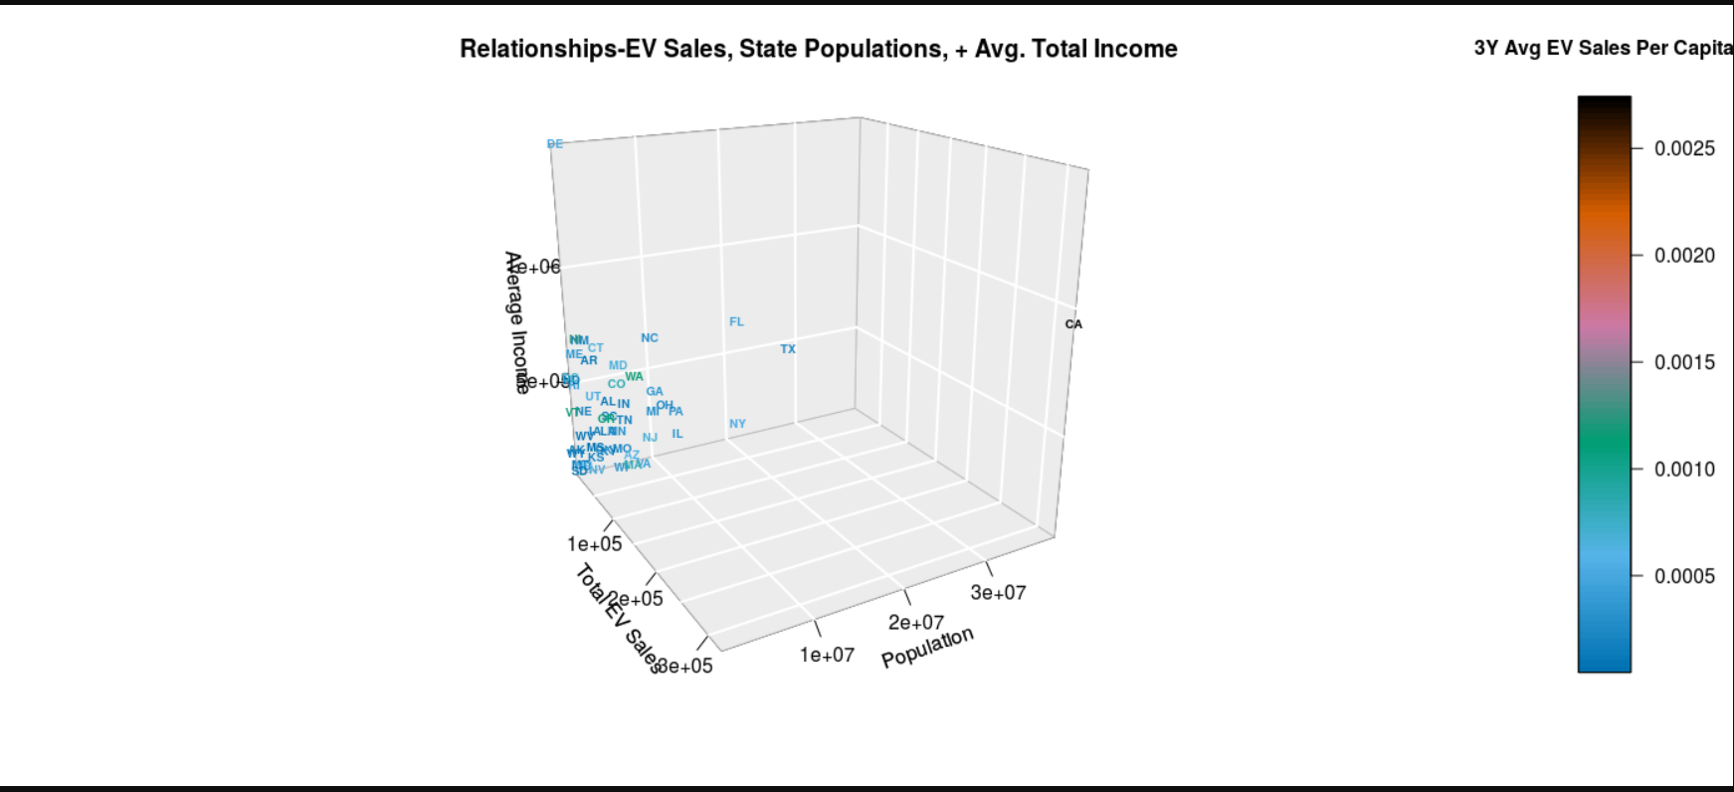

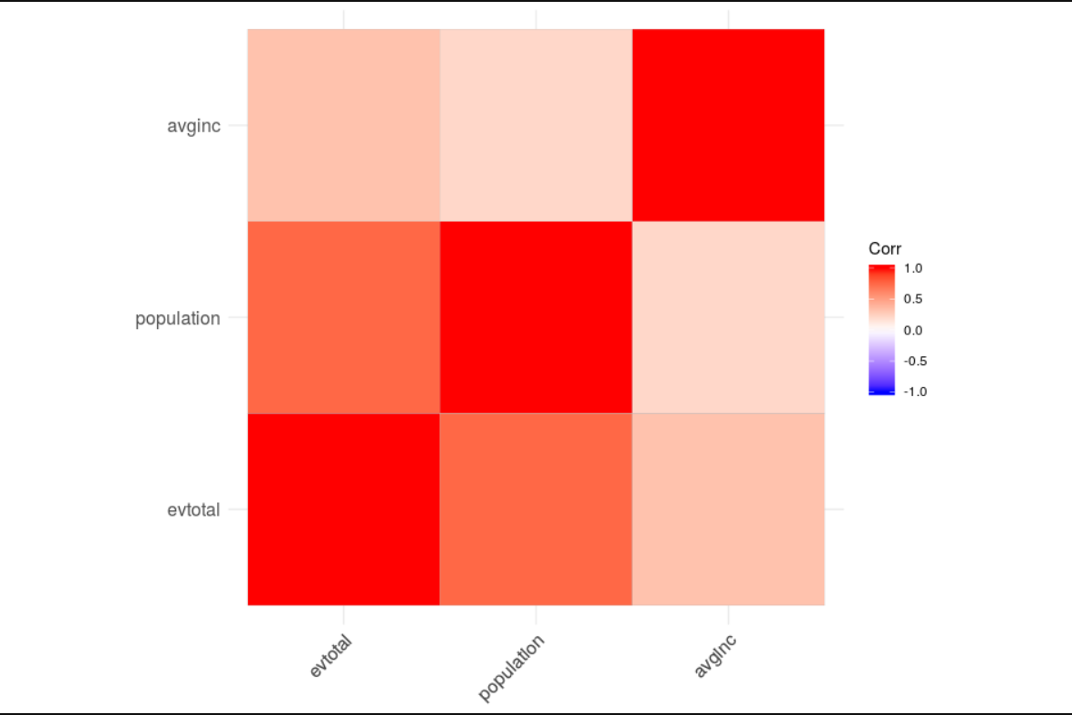

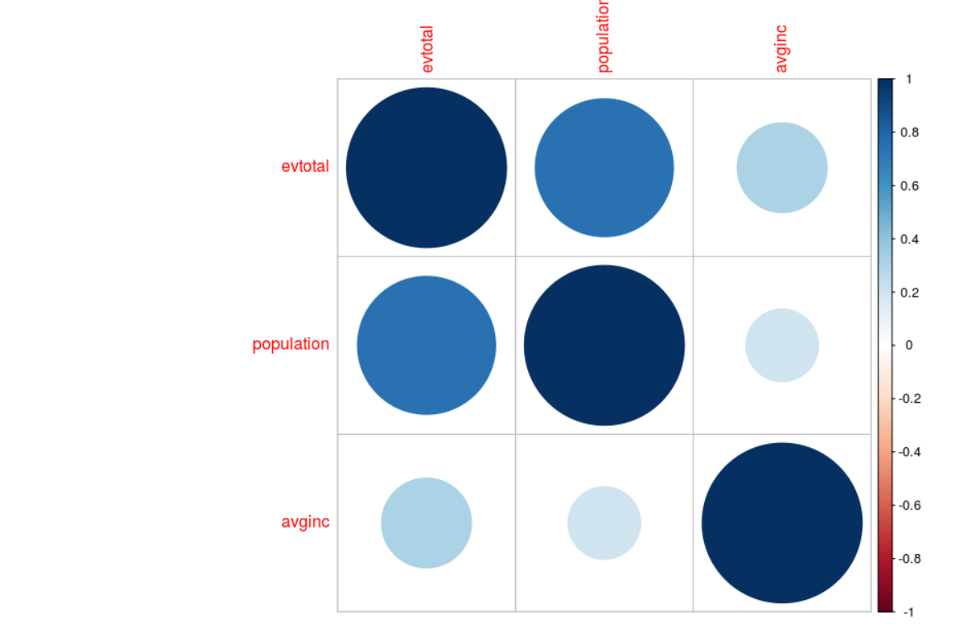

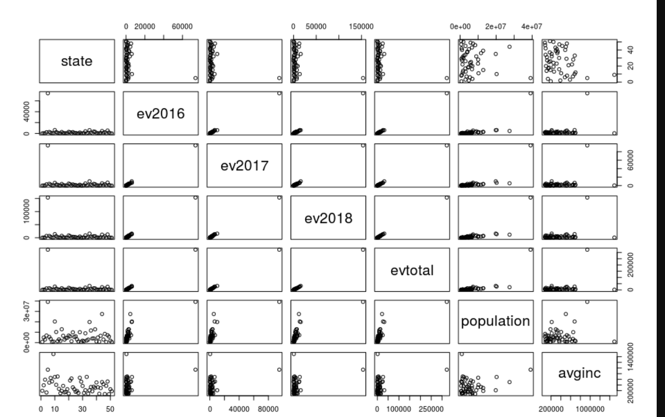

**California is the Outlier in Yellow**

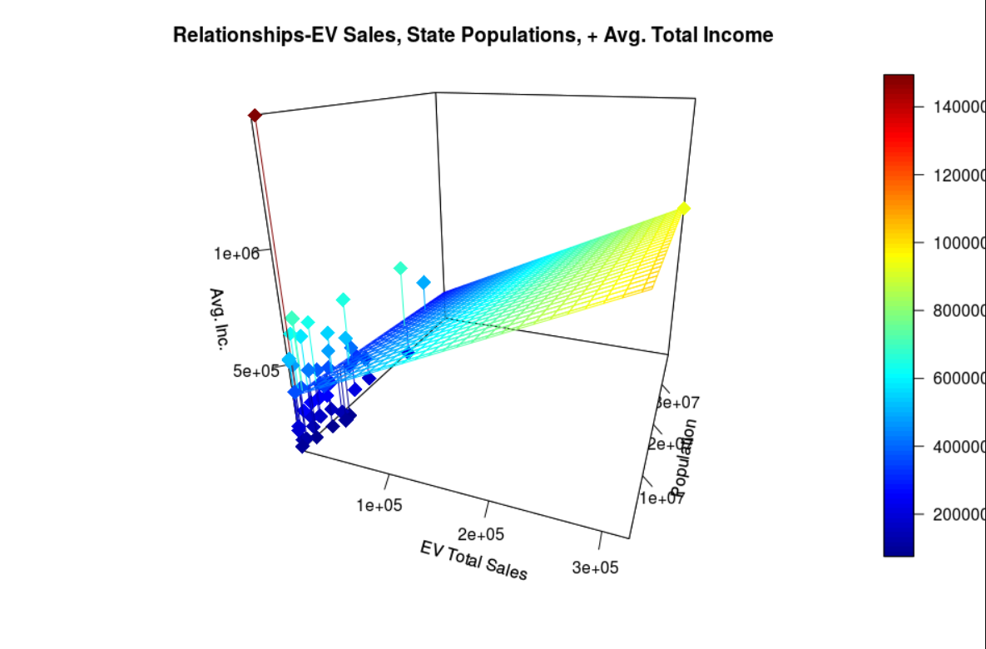

**APPENDIX**

**QUESTION 3 SQL Full 412 Row Table Results**

|  |  |  |  |  |
| --- | --- | --- | --- | --- |
|  | STATE | Zip | TOTINC | AVGINC |
| 1 | AL | 35004 | $283,221.00 | $194,519.83 |
| 2 | AL | 35007 | $701,514.00 | $194,519.83 |
| 3 | AL | 35010 | $382,646.00 | $194,519.83 |
| 4 | AL | 35016 | $361,470.00 | $194,519.83 |
| 5 | AL | 35020 | $259,289.00 | $194,519.83 |
| 6 | AL | 35022 | $552,470.00 | $194,519.83 |
| 7 | AL | 35023 | $484,788.00 | $194,519.83 |
| 8 | AL | 35040 | $399,598.00 | $194,519.83 |
| 9 | AL | 35043 | $390,635.00 | $194,519.83 |
| 10 | AL | 35045 | $256,336.00 | $194,519.83 |
| 11 | AL | 35051 | $204,773.00 | $194,519.83 |
| 12 | AL | 35055 | $413,210.00 | $194,519.83 |
| 13 | AL | 35057 | $273,337.00 | $194,519.83 |
| 14 | AL | 35058 | $216,214.00 | $194,519.83 |
| 15 | AL | 35071 | $456,043.00 | $194,519.83 |
| 16 | AL | 35077 | $220,744.00 | $194,519.83 |
| 17 | AL | 35080 | $548,303.00 | $194,519.83 |
| 18 | AL | 35094 | $344,443.00 | $194,519.83 |
| 19 | AL | 35111 | $441,344.00 | $194,519.83 |
| 20 | AL | 35115 | $233,852.00 | $194,519.83 |
| 21 | AL | 35120 | $314,475.00 | $194,519.83 |
| 22 | AL | 35121 | $300,507.00 | $194,519.83 |
| 23 | AL | 35124 | $915,969.00 | $194,519.83 |
| 24 | AL | 35126 | $513,336.00 | $194,519.83 |
| 25 | AL | 35127 | $225,090.00 | $194,519.83 |
| 26 | AL | 35128 | $243,334.00 | $194,519.83 |
| 27 | AL | 35146 | $277,018.00 | $194,519.83 |
| 28 | AL | 35150 | $301,304.00 | $194,519.83 |
| 29 | AL | 35160 | $387,795.00 | $194,519.83 |
| 30 | AL | 35173 | $1,038,614.00 | $194,519.83 |
| 31 | AL | 35180 | $318,723.00 | $194,519.83 |
| 32 | AL | 35205 | $428,236.00 | $194,519.83 |
| 33 | AL | 35206 | $201,104.00 | $194,519.83 |
| 34 | AL | 35209 | $1,134,655.00 | $194,519.83 |
| 35 | AL | 35210 | $396,253.00 | $194,519.83 |
| 36 | AL | 35211 | $341,170.00 | $194,519.83 |
| 37 | AL | 35213 | $1,502,478.00 | $194,519.83 |
| 38 | AL | 35214 | $314,661.00 | $194,519.83 |
| 39 | AL | 35215 | $700,467.00 | $194,519.83 |
| 40 | AL | 35216 | $1,479,816.00 | $194,519.83 |
| 41 | AL | 35222 | $314,460.00 | $194,519.83 |
| 42 | AL | 35223 | $1,903,031.00 | $194,519.83 |
| 43 | AL | 35226 | $1,619,591.00 | $194,519.83 |
| 44 | AL | 35235 | $400,175.00 | $194,519.83 |
| 45 | AL | 35242 | $3,359,972.00 | $194,519.83 |
| 46 | AL | 35243 | $1,512,470.00 | $194,519.83 |
| 47 | AL | 35244 | $1,546,699.00 | $194,519.83 |
| 48 | AL | 35401 | $331,038.00 | $194,519.83 |
| 49 | AL | 35404 | $333,424.00 | $194,519.83 |
| 50 | AL | 35405 | $875,050.00 | $194,519.83 |
| 51 | AL | 35406 | $858,315.00 | $194,519.83 |
| 52 | AL | 35453 | $236,801.00 | $194,519.83 |
| 53 | AL | 35473 | $401,708.00 | $194,519.83 |
| 54 | AL | 35475 | $513,756.00 | $194,519.83 |
| 55 | AL | 35504 | $313,527.00 | $194,519.83 |
| 56 | AL | 35565 | $203,707.00 | $194,519.83 |
| 57 | AL | 35601 | $630,043.00 | $194,519.83 |
| 58 | AL | 35603 | $878,339.00 | $194,519.83 |
| 59 | AL | 35611 | $474,922.00 | $194,519.83 |
| 60 | AL | 35613 | $678,179.00 | $194,519.83 |
| 61 | AL | 35630 | $557,166.00 | $194,519.83 |
| 62 | AL | 35633 | $441,672.00 | $194,519.83 |
| 63 | AL | 35634 | $348,858.00 | $194,519.83 |
| 64 | AL | 35640 | $575,726.00 | $194,519.83 |
| 65 | AL | 35645 | $368,641.00 | $194,519.83 |
| 66 | AL | 35650 | $250,496.00 | $194,519.83 |
| 67 | AL | 35653 | $196,531.00 | $194,519.83 |
| 68 | AL | 35661 | $466,837.00 | $194,519.83 |
| 69 | AL | 35674 | $395,301.00 | $194,519.83 |
| 70 | AL | 35748 | $239,211.00 | $194,519.83 |
| 71 | AL | 35749 | $741,906.00 | $194,519.83 |
| 72 | AL | 35750 | $295,415.00 | $194,519.83 |
| 73 | AL | 35756 | $559,520.00 | $194,519.83 |
| 74 | AL | 35757 | $533,533.00 | $194,519.83 |
| 75 | AL | 35758 | $1,854,632.00 | $194,519.83 |
| 76 | AL | 35759 | $256,482.00 | $194,519.83 |
| 77 | AL | 35761 | $307,410.00 | $194,519.83 |
| 78 | AL | 35763 | $799,052.00 | $194,519.83 |
| 79 | AL | 35768 | $228,044.00 | $194,519.83 |
| 80 | AL | 35769 | $276,406.00 | $194,519.83 |
| 81 | AL | 35773 | $277,516.00 | $194,519.83 |
| 82 | AL | 35801 | $1,184,174.00 | $194,519.83 |
| 83 | AL | 35802 | $984,398.00 | $194,519.83 |
| 84 | AL | 35803 | $978,788.00 | $194,519.83 |
| 85 | AL | 35805 | $225,437.00 | $194,519.83 |
| 86 | AL | 35806 | $774,520.00 | $194,519.83 |
| 87 | AL | 35810 | $449,348.00 | $194,519.83 |
| 88 | AL | 35811 | $745,655.00 | $194,519.83 |
| 89 | AL | 35824 | $309,713.00 | $194,519.83 |
| 90 | AL | 35901 | $417,728.00 | $194,519.83 |
| 91 | AL | 35903 | $276,596.00 | $194,519.83 |
| 92 | AL | 35904 | $197,007.00 | $194,519.83 |
| 93 | AL | 35906 | $236,741.00 | $194,519.83 |
| 94 | AL | 35907 | $234,116.00 | $194,519.83 |
| 95 | AL | 35950 | $345,183.00 | $194,519.83 |
| 96 | AL | 35957 | $259,544.00 | $194,519.83 |
| 97 | AL | 35967 | $262,865.00 | $194,519.83 |
| 98 | AL | 35976 | $432,165.00 | $194,519.83 |
| 99 | AL | 36022 | $349,667.00 | $194,519.83 |
| 100 | AL | 36027 | $256,462.00 | $194,519.83 |
| 101 | AL | 36037 | $232,381.00 | $194,519.83 |
| 102 | AL | 36054 | $333,267.00 | $194,519.83 |
| 103 | AL | 36064 | $436,157.00 | $194,519.83 |
| 104 | AL | 36066 | $523,472.00 | $194,519.83 |
| 105 | AL | 36067 | $578,753.00 | $194,519.83 |
| 106 | AL | 36078 | $270,889.00 | $194,519.83 |
| 107 | AL | 36081 | $276,096.00 | $194,519.83 |
| 108 | AL | 36092 | $422,507.00 | $194,519.83 |
| 109 | AL | 36093 | $408,767.00 | $194,519.83 |
| 110 | AL | 36106 | $499,677.00 | $194,519.83 |
| 111 | AL | 36108 | $221,565.00 | $194,519.83 |
| 112 | AL | 36109 | $567,459.00 | $194,519.83 |
| 113 | AL | 36111 | $398,490.00 | $194,519.83 |
| 114 | AL | 36116 | $757,627.00 | $194,519.83 |
| 115 | AL | 36117 | $1,614,930.00 | $194,519.83 |
| 116 | AL | 36203 | $419,608.00 | $194,519.83 |
| 117 | AL | 36207 | $501,891.00 | $194,519.83 |
| 118 | AL | 36265 | $362,888.00 | $194,519.83 |
| 119 | AL | 36301 | $663,628.00 | $194,519.83 |
| 120 | AL | 36303 | $732,394.00 | $194,519.83 |
| 121 | AL | 36305 | $571,890.00 | $194,519.83 |
| 122 | AL | 36330 | $852,250.00 | $194,519.83 |
| 123 | AL | 36360 | $348,456.00 | $194,519.83 |
| 124 | AL | 36420 | $225,707.00 | $194,519.83 |
| 125 | AL | 36426 | $256,086.00 | $194,519.83 |
| 126 | AL | 36502 | $254,207.00 | $194,519.83 |
| 127 | AL | 36507 | $381,199.00 | $194,519.83 |
| 128 | AL | 36526 | $1,050,774.00 | $194,519.83 |
| 129 | AL | 36527 | $564,284.00 | $194,519.83 |
| 130 | AL | 36530 | $200,404.00 | $194,519.83 |
| 131 | AL | 36532 | $1,097,184.00 | $194,519.83 |
| 132 | AL | 36535 | $515,821.00 | $194,519.83 |
| 133 | AL | 36541 | $290,989.00 | $194,519.83 |
| 134 | AL | 36542 | $355,890.00 | $194,519.83 |
| 135 | AL | 36551 | $201,253.00 | $194,519.83 |
| 136 | AL | 36561 | $294,102.00 | $194,519.83 |
| 137 | AL | 36567 | $253,917.00 | $194,519.83 |
| 138 | AL | 36571 | $386,731.00 | $194,519.83 |
| 139 | AL | 36575 | $428,166.00 | $194,519.83 |
| 140 | AL | 36582 | $474,690.00 | $194,519.83 |
| 141 | AL | 36587 | $202,475.00 | $194,519.83 |
| 142 | AL | 36604 | $212,018.00 | $194,519.83 |
| 143 | AL | 36605 | $383,288.00 | $194,519.83 |
| 144 | AL | 36606 | $347,575.00 | $194,519.83 |
| 145 | AL | 36608 | $1,189,331.00 | $194,519.83 |
| 146 | AL | 36609 | $499,982.00 | $194,519.83 |
| 147 | AL | 36618 | $302,312.00 | $194,519.83 |
| 148 | AL | 36619 | $354,247.00 | $194,519.83 |
| 149 | AL | 36693 | $530,227.00 | $194,519.83 |
| 150 | AL | 36695 | $1,424,343.00 | $194,519.83 |
| 151 | AL | 36701 | $367,300.00 | $194,519.83 |
| 152 | AL | 36801 | $479,467.00 | $194,519.83 |
| 153 | AL | 36804 | $359,039.00 | $194,519.83 |
| 154 | AL | 36830 | $1,254,812.00 | $194,519.83 |
| 155 | AL | 36832 | $346,645.00 | $194,519.83 |
| 156 | AL | 36853 | $195,253.00 | $194,519.83 |
| 157 | AL | 36854 | $268,022.00 | $194,519.83 |
| 158 | AL | 36867 | $379,361.00 | $194,519.83 |
| 159 | AL | 36869 | $278,859.00 | $194,519.83 |
| 160 | AL | 36870 | $335,612.00 | $194,519.83 |
| 161 | AL | 36877 | $246,388.00 | $194,519.83 |
| 162 | AR | 71601 | $160,993.00 | $135,790.69 |
| 163 | AR | 71602 | $337,766.00 | $135,790.69 |
| 164 | AR | 71603 | $575,528.00 | $135,790.69 |
| 165 | AR | 71635 | $220,217.00 | $135,790.69 |
| 166 | AR | 71655 | $265,364.00 | $135,790.69 |
| 167 | AR | 71671 | $144,129.00 | $135,790.69 |
| 168 | AR | 71701 | $326,190.00 | $135,790.69 |
| 169 | AR | 71730 | $800,310.00 | $135,790.69 |
| 170 | AR | 71753 | $293,915.00 | $135,790.69 |
| 171 | AR | 71801 | $219,904.00 | $135,790.69 |
| 172 | AR | 71822 | $151,623.00 | $135,790.69 |
| 173 | AR | 71832 | $154,226.00 | $135,790.69 |
| 174 | AR | 71852 | $169,413.00 | $135,790.69 |
| 175 | AR | 71854 | $717,738.00 | $135,790.69 |
| 176 | AR | 71901 | $593,027.00 | $135,790.69 |
| 177 | AR | 71909 | $530,039.00 | $135,790.69 |
| 178 | AR | 71913 | $1,034,535.00 | $135,790.69 |
| 179 | AR | 71923 | $290,464.00 | $135,790.69 |
| 180 | AR | 71953 | $233,320.00 | $135,790.69 |
| 181 | AR | 72002 | $401,218.00 | $135,790.69 |
| 182 | AR | 72007 | $194,082.00 | $135,790.69 |
| 183 | AR | 72012 | $278,627.00 | $135,790.69 |
| 184 | AR | 72015 | $556,988.00 | $135,790.69 |
| 185 | AR | 72019 | $755,023.00 | $135,790.69 |
| 186 | AR | 72022 | $438,548.00 | $135,790.69 |
| 187 | AR | 72023 | $902,738.00 | $135,790.69 |
| 188 | AR | 72032 | $637,320.00 | $135,790.69 |
| 189 | AR | 72034 | $1,216,425.00 | $135,790.69 |
| 190 | AR | 72058 | $394,081.00 | $135,790.69 |
| 191 | AR | 72076 | $653,162.00 | $135,790.69 |
| 192 | AR | 72086 | $213,776.00 | $135,790.69 |
| 193 | AR | 72103 | $240,148.00 | $135,790.69 |
| 194 | AR | 72104 | $369,475.00 | $135,790.69 |
| 195 | AR | 72110 | $234,898.00 | $135,790.69 |
| 196 | AR | 72112 | $151,340.00 | $135,790.69 |
| 197 | AR | 72113 | $899,478.00 | $135,790.69 |
| 198 | AR | 72116 | $742,401.00 | $135,790.69 |
| 199 | AR | 72117 | $194,277.00 | $135,790.69 |
| 200 | AR | 72118 | $392,295.00 | $135,790.69 |
| 201 | AR | 72120 | $945,449.00 | $135,790.69 |
| 202 | AR | 72143 | $719,777.00 | $135,790.69 |
| 203 | AR | 72150 | $279,206.00 | $135,790.69 |
| 204 | AR | 72160 | $253,084.00 | $135,790.69 |
| 205 | AR | 72173 | $214,182.00 | $135,790.69 |
| 206 | AR | 72176 | $167,276.00 | $135,790.69 |
| 207 | AR | 72202 | $274,108.00 | $135,790.69 |
| 208 | AR | 72204 | $424,688.00 | $135,790.69 |
| 209 | AR | 72205 | $682,503.00 | $135,790.69 |
| 210 | AR | 72206 | $364,088.00 | $135,790.69 |
| 211 | AR | 72207 | $924,013.00 | $135,790.69 |
| 212 | AR | 72209 | $364,589.00 | $135,790.69 |
| 213 | AR | 72210 | $404,702.00 | $135,790.69 |
| 214 | AR | 72211 | $830,077.00 | $135,790.69 |
| 215 | AR | 72212 | $806,084.00 | $135,790.69 |
| 216 | AR | 72223 | $1,633,065.00 | $135,790.69 |
| 217 | AR | 72227 | $512,846.00 | $135,790.69 |
| 218 | AR | 72301 | $356,380.00 | $135,790.69 |
| 219 | AR | 72315 | $350,462.00 | $135,790.69 |
| 220 | AR | 72335 | $175,047.00 | $135,790.69 |
| 221 | AR | 72364 | $389,425.00 | $135,790.69 |
| 222 | AR | 72396 | $254,142.00 | $135,790.69 |
| 223 | AR | 72401 | $1,039,724.00 | $135,790.69 |
| 224 | AR | 72404 | $824,426.00 | $135,790.69 |
| 225 | AR | 72450 | $709,543.00 | $135,790.69 |
| 226 | AR | 72455 | $208,530.00 | $135,790.69 |
| 227 | AR | 72501 | $470,509.00 | $135,790.69 |
| 228 | AR | 72543 | $267,035.00 | $135,790.69 |
| 229 | AR | 72560 | $136,971.00 | $135,790.69 |
| 230 | AR | 72601 | $524,624.00 | $135,790.69 |
| 231 | AR | 72616 | $176,503.00 | $135,790.69 |
| 232 | AR | 72653 | $589,240.00 | $135,790.69 |
| 233 | AR | 72701 | $983,373.00 | $135,790.69 |
| 234 | AR | 72703 | $1,085,754.00 | $135,790.69 |
| 235 | AR | 72704 | $773,636.00 | $135,790.69 |
| 236 | AR | 72712 | $4,948,326.00 | $135,790.69 |
| 237 | AR | 72714 | $404,210.00 | $135,790.69 |
| 238 | AR | 72715 | $509,403.00 | $135,790.69 |
| 239 | AR | 72718 | $139,384.00 | $135,790.69 |
| 240 | AR | 72719 | $330,981.00 | $135,790.69 |
| 241 | AR | 72730 | $228,966.00 | $135,790.69 |
| 242 | AR | 72734 | $141,626.00 | $135,790.69 |
| 243 | AR | 72736 | $140,422.00 | $135,790.69 |
| 244 | AR | 72740 | $163,588.00 | $135,790.69 |
| 245 | AR | 72745 | $303,484.00 | $135,790.69 |
| 246 | AR | 72751 | $150,123.00 | $135,790.69 |
| 247 | AR | 72753 | $188,371.00 | $135,790.69 |
| 248 | AR | 72756 | $942,343.00 | $135,790.69 |
| 249 | AR | 72758 | $1,601,440.00 | $135,790.69 |
| 250 | AR | 72761 | $444,801.00 | $135,790.69 |
| 251 | AR | 72762 | $1,090,600.00 | $135,790.69 |
| 252 | AR | 72764 | $997,426.00 | $135,790.69 |
| 253 | AR | 72801 | $253,587.00 | $135,790.69 |
| 254 | AR | 72802 | $548,611.00 | $135,790.69 |
| 255 | AR | 72830 | $244,584.00 | $135,790.69 |
| 256 | AR | 72834 | $170,452.00 | $135,790.69 |
| 257 | AR | 72837 | $167,197.00 | $135,790.69 |
| 258 | AR | 72901 | $324,165.00 | $135,790.69 |
| 259 | AR | 72903 | $715,547.00 | $135,790.69 |
| 260 | AR | 72904 | $237,997.00 | $135,790.69 |
| 261 | AR | 72908 | $359,883.00 | $135,790.69 |
| 262 | AR | 72916 | $350,933.00 | $135,790.69 |
| 263 | AR | 72921 | $270,414.00 | $135,790.69 |
| 264 | AR | 72936 | $366,658.00 | $135,790.69 |
| 265 | AR | 72949 | $167,048.00 | $135,790.69 |
| 266 | AR | 72956 | $610,723.00 | $135,790.69 |
| 267 | AZ | 85008 | $801,661.00 | $587,192.91 |
| 268 | AZ | 85013 | $664,538.00 | $587,192.91 |
| 269 | AZ | 85014 | $757,118.00 | $587,192.91 |
| 270 | AZ | 85016 | $1,675,150.00 | $587,192.91 |
| 271 | AZ | 85018 | $2,374,087.00 | $587,192.91 |
| 272 | AZ | 85020 | $1,153,614.00 | $587,192.91 |
| 273 | AZ | 85021 | $1,012,065.00 | $587,192.91 |
| 274 | AZ | 85022 | $1,384,648.00 | $587,192.91 |
| 275 | AZ | 85023 | $888,118.00 | $587,192.91 |
| 276 | AZ | 85024 | $791,923.00 | $587,192.91 |
| 277 | AZ | 85027 | $863,987.00 | $587,192.91 |
| 278 | AZ | 85028 | $1,028,811.00 | $587,192.91 |
| 279 | AZ | 85029 | $779,911.00 | $587,192.91 |
| 280 | AZ | 85032 | $1,608,158.00 | $587,192.91 |
| 281 | AZ | 85033 | $611,143.00 | $587,192.91 |
| 282 | AZ | 85037 | $715,888.00 | $587,192.91 |
| 283 | AZ | 85041 | $906,191.00 | $587,192.91 |
| 284 | AZ | 85042 | $827,476.00 | $587,192.91 |
| 285 | AZ | 85044 | $1,599,615.00 | $587,192.91 |
| 286 | AZ | 85048 | $1,715,934.00 | $587,192.91 |
| 287 | AZ | 85050 | $1,391,893.00 | $587,192.91 |
| 288 | AZ | 85051 | $617,914.00 | $587,192.91 |
| 289 | AZ | 85083 | $804,055.00 | $587,192.91 |
| 290 | AZ | 85085 | $930,133.00 | $587,192.91 |
| 291 | AZ | 85086 | $1,464,508.00 | $587,192.91 |
| 292 | AZ | 85122 | $881,505.00 | $587,192.91 |
| 293 | AZ | 85138 | $767,878.00 | $587,192.91 |
| 294 | AZ | 85140 | $731,695.00 | $587,192.91 |
| 295 | AZ | 85142 | $1,695,634.00 | $587,192.91 |
| 296 | AZ | 85143 | $665,221.00 | $587,192.91 |
| 297 | AZ | 85201 | $739,064.00 | $587,192.91 |
| 298 | AZ | 85202 | $822,604.00 | $587,192.91 |
| 299 | AZ | 85203 | $796,974.00 | $587,192.91 |
| 300 | AZ | 85204 | $993,013.00 | $587,192.91 |
| 301 | AZ | 85205 | $1,037,062.00 | $587,192.91 |
| 302 | AZ | 85206 | $761,466.00 | $587,192.91 |
| 303 | AZ | 85207 | $1,634,986.00 | $587,192.91 |
| 304 | AZ | 85208 | $606,996.00 | $587,192.91 |
| 305 | AZ | 85209 | $975,204.00 | $587,192.91 |
| 306 | AZ | 85210 | $626,868.00 | $587,192.91 |
| 307 | AZ | 85212 | $886,109.00 | $587,192.91 |
| 308 | AZ | 85213 | $1,125,944.00 | $587,192.91 |
| 309 | AZ | 85224 | $1,386,617.00 | $587,192.91 |
| 310 | AZ | 85225 | $1,644,789.00 | $587,192.91 |
| 311 | AZ | 85226 | $1,482,481.00 | $587,192.91 |
| 312 | AZ | 85233 | $1,242,299.00 | $587,192.91 |
| 313 | AZ | 85234 | $1,815,012.00 | $587,192.91 |
| 314 | AZ | 85248 | $1,650,814.00 | $587,192.91 |
| 315 | AZ | 85249 | $1,981,034.00 | $587,192.91 |
| 316 | AZ | 85250 | $807,331.00 | $587,192.91 |
| 317 | AZ | 85251 | $1,810,698.00 | $587,192.91 |
| 318 | AZ | 85253 | $3,560,948.00 | $587,192.91 |
| 319 | AZ | 85254 | $2,459,698.00 | $587,192.91 |
| 320 | AZ | 85255 | $4,531,297.00 | $587,192.91 |
| 321 | AZ | 85257 | $785,575.00 | $587,192.91 |
| 322 | AZ | 85258 | $1,618,341.00 | $587,192.91 |
| 323 | AZ | 85259 | $1,889,642.00 | $587,192.91 |
| 324 | AZ | 85260 | $2,217,921.00 | $587,192.91 |
| 325 | AZ | 85262 | $1,515,629.00 | $587,192.91 |
| 326 | AZ | 85266 | $975,054.00 | $587,192.91 |
| 327 | AZ | 85268 | $1,196,095.00 | $587,192.91 |
| 328 | AZ | 85281 | $981,467.00 | $587,192.91 |
| 329 | AZ | 85282 | $1,246,811.00 | $587,192.91 |
| 330 | AZ | 85283 | $1,194,111.00 | $587,192.91 |
| 331 | AZ | 85284 | $1,261,453.00 | $587,192.91 |
| 332 | AZ | 85286 | $1,701,255.00 | $587,192.91 |
| 333 | AZ | 85295 | $1,476,885.00 | $587,192.91 |
| 334 | AZ | 85296 | $1,468,146.00 | $587,192.91 |
| 335 | AZ | 85297 | $1,142,786.00 | $587,192.91 |
| 336 | AZ | 85298 | $1,426,868.00 | $587,192.91 |
| 337 | AZ | 85301 | $655,169.00 | $587,192.91 |
| 338 | AZ | 85302 | $691,209.00 | $587,192.91 |
| 339 | AZ | 85304 | $661,882.00 | $587,192.91 |
| 340 | AZ | 85308 | $2,049,651.00 | $587,192.91 |
| 341 | AZ | 85310 | $789,521.00 | $587,192.91 |
| 342 | AZ | 85323 | $627,620.00 | $587,192.91 |
| 343 | AZ | 85326 | $1,001,457.00 | $587,192.91 |
| 344 | AZ | 85331 | $1,455,589.00 | $587,192.91 |
| 345 | AZ | 85338 | $1,270,401.00 | $587,192.91 |
| 346 | AZ | 85339 | $905,957.00 | $587,192.91 |
| 347 | AZ | 85340 | $1,026,591.00 | $587,192.91 |
| 348 | AZ | 85345 | $1,060,614.00 | $587,192.91 |
| 349 | AZ | 85351 | $595,851.00 | $587,192.91 |
| 350 | AZ | 85353 | $623,251.00 | $587,192.91 |
| 351 | AZ | 85364 | $1,287,414.00 | $587,192.91 |
| 352 | AZ | 85365 | $959,879.00 | $587,192.91 |
| 353 | AZ | 85374 | $1,009,556.00 | $587,192.91 |
| 354 | AZ | 85375 | $840,894.00 | $587,192.91 |
| 355 | AZ | 85379 | $1,021,894.00 | $587,192.91 |
| 356 | AZ | 85381 | $763,026.00 | $587,192.91 |
| 357 | AZ | 85382 | $1,296,690.00 | $587,192.91 |
| 358 | AZ | 85383 | $2,148,172.00 | $587,192.91 |
| 359 | AZ | 85388 | $627,849.00 | $587,192.91 |
| 360 | AZ | 85392 | $860,956.00 | $587,192.91 |
| 361 | AZ | 85395 | $1,055,071.00 | $587,192.91 |
| 362 | AZ | 85614 | $661,981.00 | $587,192.91 |
| 363 | AZ | 85629 | $676,569.00 | $587,192.91 |
| 364 | AZ | 85635 | $765,986.00 | $587,192.91 |
| 365 | AZ | 85641 | $805,670.00 | $587,192.91 |
| 366 | AZ | 85704 | $1,035,837.00 | $587,192.91 |
| 367 | AZ | 85705 | $603,071.00 | $587,192.91 |
| 368 | AZ | 85710 | $1,093,883.00 | $587,192.91 |
| 369 | AZ | 85711 | $722,139.00 | $587,192.91 |
| 370 | AZ | 85712 | $626,944.00 | $587,192.91 |
| 371 | AZ | 85715 | $655,074.00 | $587,192.91 |
| 372 | AZ | 85716 | $670,221.00 | $587,192.91 |
| 373 | AZ | 85718 | $2,011,831.00 | $587,192.91 |
| 374 | AZ | 85719 | $627,581.00 | $587,192.91 |
| 375 | AZ | 85730 | $740,142.00 | $587,192.91 |
| 376 | AZ | 85737 | $977,010.00 | $587,192.91 |
| 377 | AZ | 85739 | $628,489.00 | $587,192.91 |
| 378 | AZ | 85741 | $762,252.00 | $587,192.91 |
| 379 | AZ | 85742 | $797,406.00 | $587,192.91 |
| 380 | AZ | 85743 | $851,808.00 | $587,192.91 |
| 381 | AZ | 85745 | $939,484.00 | $587,192.91 |
| 382 | AZ | 85746 | $623,407.00 | $587,192.91 |
| 383 | AZ | 85747 | $732,397.00 | $587,192.91 |
| 384 | AZ | 85748 | $676,572.00 | $587,192.91 |
| 385 | AZ | 85749 | $967,117.00 | $587,192.91 |
| 386 | AZ | 85750 | $1,473,384.00 | $587,192.91 |
| 387 | AZ | 85755 | $790,376.00 | $587,192.91 |
| 388 | AZ | 86001 | $784,390.00 | $587,192.91 |
| 389 | AZ | 86004 | $969,727.00 | $587,192.91 |
| 390 | AZ | 86301 | $641,829.00 | $587,192.91 |
| 391 | AZ | 86305 | $725,866.00 | $587,192.91 |
| 392 | AZ | 86314 | $640,960.00 | $587,192.91 |
| 393 | AK | 99501 | $640,556.00 | $389,999.00 |
| 394 | AK | 99502 | $1,086,686.00 | $389,999.00 |
| 395 | AK | 99503 | $517,361.00 | $389,999.00 |
| 396 | AK | 99504 | $1,186,170.00 | $389,999.00 |
| 397 | AK | 99507 | $1,587,097.00 | $389,999.00 |
| 398 | AK | 99508 | $942,822.00 | $389,999.00 |
| 399 | AK | 99515 | $1,068,994.00 | $389,999.00 |
| 400 | AK | 99516 | $1,488,457.00 | $389,999.00 |
| 401 | AK | 99517 | $682,670.00 | $389,999.00 |
| 402 | AK | 99577 | $1,194,184.00 | $389,999.00 |
| 403 | AK | 99611 | $488,077.00 | $389,999.00 |
| 404 | AK | 99615 | $417,500.00 | $389,999.00 |
| 405 | AK | 99645 | $994,409.00 | $389,999.00 |
| 406 | AK | 99654 | $1,034,440.00 | $389,999.00 |
| 407 | AK | 99669 | $612,816.00 | $389,999.00 |
| 408 | AK | 99701 | $493,105.00 | $389,999.00 |
| 409 | AK | 99705 | $618,593.00 | $389,999.00 |
| 410 | AK | 99709 | $841,897.00 | $389,999.00 |
| 411 | AK | 99801 | $882,488.00 | $389,999.00 |
| 412 | AK | 99901 | $419,627.00 | $389,999.00 |

**QUESTION 4 SQL PARTITION BY Method 50 States**

|  |  |  |  |  |
| --- | --- | --- | --- | --- |
|  | ROWNUMBER | STATE | Zip | TOPAGI |
| 1 | 1 | CA | 94301 | $10,296,266.00 |
| 2 | 1 | KY | 41017 | $2,404,558.00 |
| 3 | 1 | MO | 63017 | $2,833,698.00 |
| 4 | 1 | AK | 99507 | $1,564,350.00 |
| 5 | 1 | NJ | 07030 | $4,657,261.00 |
| 6 | 1 | AL | 35242 | $3,300,440.00 |
| 7 | 1 | ID | 83646 | $1,618,072.00 |
| 8 | 1 | IL | 60611 | $7,952,291.00 |
| 9 | 1 | NC | 28277 | $3,909,028.00 |
| 10 | 1 | PA | 19087 | $3,483,611.00 |
| 11 | 1 | WV | 26508 | $1,363,247.00 |
| 12 | 1 | FL | 33480 | $6,887,326.00 |
| 13 | 1 | KS | 66062 | $2,717,450.00 |
| 14 | 1 | MA | 02116 | $5,563,788.00 |
| 15 | 1 | MI | 48103 | $2,756,404.00 |
| 16 | 1 | ND | 58104 | $1,630,855.00 |
| 17 | 1 | SC | 29464 | $2,680,516.00 |
| 18 | 1 | TN | 37027 | $4,658,577.00 |
| 19 | 1 | VT | 05403 | $826,051.00 |
| 20 | 1 | HI | 96816 | $2,070,480.00 |
| 21 | 1 | DE | 19711 | $1,785,082.00 |
| 22 | 1 | IN | 46032 | $3,392,527.00 |
| 23 | 1 | NE | 68516 | $1,881,267.00 |
| 24 | 1 | NM | 87111 | $2,248,500.00 |
| 25 | 1 | OH | 45040 | $2,707,826.00 |
| 26 | 1 | SD | 57108 | $1,590,154.00 |
| 27 | 1 | CT | 06830 | $7,242,398.00 |
| 28 | 1 | RI | 02906 | $1,509,876.00 |
| 29 | 1 | GA | 30327 | $4,953,938.00 |
| 30 | 1 | MS | 39110 | $2,175,211.00 |
| 31 | 1 | NV | 89052 | $3,417,061.00 |
| 32 | 1 | TX | 77024 | $8,684,531.00 |
| 33 | 1 | WA | 98004 | $4,469,557.00 |
| 34 | 1 | WI | 53217 | $2,909,176.00 |
| 35 | 1 | WY | 82009 | $1,343,206.00 |
| 36 | 1 | LA | 70810 | $2,092,957.00 |
| 37 | 1 | MD | 20854 | $6,370,883.00 |
| 38 | 1 | MT | 59102 | $1,478,630.00 |
| 39 | 1 | OR | 97229 | $3,952,039.00 |
| 40 | 1 | UT | 84020 | $2,015,237.00 |
| 41 | 1 | CO | 80134 | $3,227,230.00 |
| 42 | 1 | IA | 52722 | $1,778,811.00 |
| 43 | 1 | ME | 04401 | $1,075,069.00 |
| 44 | 1 | OK | 73013 | $2,761,652.00 |
| 45 | 1 | NH | 03110 | $1,531,391.00 |
| 46 | 1 | AZ | 85255 | $4,451,010.00 |
| 47 | 1 | AR | 72712 | $4,928,494.00 |
| 48 | 1 | MN | 55391 | $2,723,441.00 |
| 49 | 1 | NY | 10021 | $13,597,373.00 |
| 50 | 1 | VA | 22101 | $5,032,226.00 |

**QUESTION 4 SQL PARTITION BY Method 51 States (including Washington DC)**

|  |  |  |  |  |
| --- | --- | --- | --- | --- |
|  | ROWNUMBER | STATE | Zip | TOPAGI |
| 1 | 1 | CA | 94301 | $10,296,266.00 |
| 2 | 1 | KY | 41017 | $2,404,558.00 |
| 3 | 1 | MO | 63017 | $2,833,698.00 |
| 4 | 1 | AK | 99507 | $1,564,350.00 |
| 5 | 1 | NJ | 07030 | $4,657,261.00 |
| 6 | 1 | AL | 35242 | $3,300,440.00 |
| 7 | 1 | ID | 83646 | $1,618,072.00 |
| 8 | 1 | IL | 60611 | $7,952,291.00 |
| 9 | 1 | NC | 28277 | $3,909,028.00 |
| 10 | 1 | PA | 19087 | $3,483,611.00 |
| 11 | 1 | WV | 26508 | $1,363,247.00 |
| 12 | 1 | FL | 33480 | $6,887,326.00 |
| 13 | 1 | KS | 66062 | $2,717,450.00 |
| 14 | 1 | MA | 02116 | $5,563,788.00 |
| 15 | 1 | MI | 48103 | $2,756,404.00 |
| 16 | 1 | ND | 58104 | $1,630,855.00 |
| 17 | 1 | SC | 29464 | $2,680,516.00 |
| 18 | 1 | TN | 37027 | $4,658,577.00 |
| 19 | 1 | VT | 05403 | $826,051.00 |
| 20 | 1 | HI | 96816 | $2,070,480.00 |
| 21 | 1 | DE | 19711 | $1,785,082.00 |
| 22 | 1 | IN | 46032 | $3,392,527.00 |
| 23 | 1 | NE | 68516 | $1,881,267.00 |
| 24 | 1 | NM | 87111 | $2,248,500.00 |
| 25 | 1 | OH | 45040 | $2,707,826.00 |
| 26 | 1 | SD | 57108 | $1,590,154.00 |
| 27 | 1 | CT | 06830 | $7,242,398.00 |
| 28 | 1 | RI | 02906 | $1,509,876.00 |
| 29 | 1 | GA | 30327 | $4,953,938.00 |
| 30 | 1 | MS | 39110 | $2,175,211.00 |
| 31 | 1 | NV | 89052 | $3,417,061.00 |
| 32 | 1 | TX | 77024 | $8,684,531.00 |
| 33 | 1 | WA | 98004 | $4,469,557.00 |
| 34 | 1 | WI | 53217 | $2,909,176.00 |
| 35 | 1 | WY | 82009 | $1,343,206.00 |
| 36 | 1 | LA | 70810 | $2,092,957.00 |
| 37 | 1 | MD | 20854 | $6,370,883.00 |
| 38 | 1 | MT | 59102 | $1,478,630.00 |
| 39 | 1 | OR | 97229 | $3,952,039.00 |
| 40 | 1 | UT | 84020 | $2,015,237.00 |
| 41 | 1 | CO | 80134 | $3,227,230.00 |
| 42 | 1 | IA | 52722 | $1,778,811.00 |
| 43 | 1 | ME | 04401 | $1,075,069.00 |
| 44 | 1 | OK | 73013 | $2,761,652.00 |
| 45 | 1 | NH | 03110 | $1,531,391.00 |
| 46 | 1 | AZ | 85255 | $4,451,010.00 |
| 47 | 1 | AR | 72712 | $4,928,494.00 |
| 48 | 1 | MN | 55391 | $2,723,441.00 |
| 49 | 1 | NY | 10021 | $13,597,373.00 |
| 50 | 1 | VA | 22101 | $5,032,226.00 |
| 51 | 1 | DC | 20016 | $3,882,614.00 |
|  |  |  |  |  |

**FULL SQL CODE**

**CREATE COLUMN TABLE "GBI_807"."GBI_807::group.EV" AS (SELECT * FROM "GBI_807"."GBI_807::g6.EV"); /* creates new tables */**

**CREATE COLUMN TABLE "GBI_807"."GBI_807::group.SP" AS (SELECT * FROM "GBI_807"."GBI_807::g6.SP"); /* good to have backup */**

**CREATE COLUMN TABLE "GBI_807"."GBI_807::group.DD" AS (SELECT * FROM "GBI_807"."GBI_807::g6.DD"); /* in case mess up */**

**/* To delete aggregated numbers for states in Demographic Data-we can calculate */**

**DELETE FROM "GBI_807"."GBI_807::group.DD"**

**WHERE "Zip" IN ('00000', '99999');**

**/* 1. List the top 10 states by total electric vehicle sales (descending order) */**

**/* 2016 */**

**SELECT TOP 10 "State", "EVSales2016" AS EV2016**

**FROM "GBI_807"."GBI_807::group.EV"**

**GROUP BY "State", "EVSales2016"**

**ORDER BY EV2016 DESC;**

**/* 2017 */**

**SELECT TOP 10 "State", "EVSales2017" AS EV2017**

**FROM "GBI_807"."GBI_807::group.EV"**

**GROUP BY "State", "EVSales2017"**

**ORDER BY EV2017 DESC;**

**/* 2018 */**

**SELECT TOP 10 "State", "EVSales2018" AS EV2018**

**FROM "GBI_807"."GBI_807::group.EV"**

**GROUP BY "State", "EVSales2018"**

**ORDER BY EV2018 DESC;**

**/* 2016-2018 Combined */**

**SELECT TOP 10 "State", ("EVSales2016"+"EVSales2017"+"EVSales2018") AS TotalEV**

**FROM "GBI_807"."GBI_807::group.EV"**

**GROUP BY "State", "EVSales2016", "EVSales2017", "EVSales2018"**

**ORDER BY TotalEV DESC;**

**/* 2. List the top 10 states by number of electric vehicle sales per capita (descending order) */**

**/* 2016 */**

**SELECT TOP 10 "State", ("EVSales2016"/"Population2015") AS PERCAPITA16**

**FROM "GBI_807"."GBI_807::group.EV" AS EV INNER JOIN "GBI_807"."GBI_807::group.SP" AS SP ON EV."State"=SP."Locale"**

**GROUP BY "State", "EVSales2016", "Population2015"**

**ORDER BY PERCAPITA16 DESC;**

**/* 2017 */**

**SELECT TOP 10 "State", ("EVSales2017"/"Population2015") AS PERCAPITA17**

**FROM "GBI_807"."GBI_807::group.EV" AS EV INNER JOIN "GBI_807"."GBI_807::group.SP" AS SP ON EV."State"=SP."Locale"**

**GROUP BY "State", "EVSales2017", "Population2015"**

**ORDER BY PERCAPITA17 DESC;**

**/* 2018 */**

**SELECT TOP 10 "State", ("EVSales2018"/"Population2015") AS PERCAPITA18**

**FROM "GBI_807"."GBI_807::group.EV" AS EV INNER JOIN "GBI_807"."GBI_807::group.SP" AS SP ON EV."State"=SP."Locale"**

**GROUP BY "State", "EVSales2018", "Population2015"**

**ORDER BY PERCAPITA18 DESC;**

**/* To get Per Capita per year averaged */**

**SELECT TOP 10 "State", (("EVSales2016"+"EVSales2017"+"EVSales2018")/("Population2015"*3)) AS PERCAPITAAVG**

**FROM "GBI_807"."GBI_807::group.EV" AS EV INNER JOIN "GBI_807"."GBI_807::group.SP" AS SP ON EV."State"=SP."Locale"**

**GROUP BY "State", "EVSales2016", "EVSales2017", "EVSales2018", "Population2015"**

**ORDER BY PERCAPITAAVG DESC;**

**/* To get percap over 3Y */**

**SELECT TOP 10 "State", (("EVSales2016"+"EVSales2017"+"EVSales2018")/"Population2015") AS PERCAPITA3Y**

**FROM "GBI_807"."GBI_807::group.EV" AS EV INNER JOIN "GBI_807"."GBI_807::group.SP" AS SP ON EV."State"=SP."Locale"**

**GROUP BY "State", "EVSales2016", "EVSales2017", "EVSales2018", "Population2015"**

**ORDER BY PERCAPITA3Y DESC;**

**/* 3. List for states beginning with 'A', the zip codes with total incomes greater than the average for the state */**

**SELECT DD2."STATE", DD2."Zip", CONCAT ('$ ',TO_DECIMAL(DD2."TotalIncome", 10, 2)) AS TOTINC,**

**CONCAT ('$ ',TO_DECIMAL(DD1."AVGINC", 10, 2)) AS AVGINC /* To remove AVGINC from results, remove DD1."AVGINC here */**

**FROM "GBI_807"."GBI_807::group.DD" AS DD2**

**, (SELECT "STATE", SUM("TotalIncome")/COUNT(DISTINCT "Zip") AS AVGINC, AVG("TotalIncome") AS AVGTOTAL**

**FROM "GBI_807"."GBI_807::group.DD"**

**GROUP BY "STATE"**

**)**

**AS DD1**

**WHERE DD2."STATE" LIKE ('A%') AND DD2."STATE" = DD1."STATE"**

**AND DD2."TotalIncome">DD1."AVGINC";**

**/* 4. List for each state, the top zip code by AGI? */**

**/* Including Washington DC */**

**SELECT DD1."STATE", DD1."Zip", CONCAT ('$ ',TO_DECIMAL(DD2."TOPAGI", 10, 2)) AS TOPAGI**

**FROM "GBI_807"."GBI_807::group.DD" AS DD1**

**INNER JOIN (SELECT "STATE",MAX(AGI) AS TOPAGI**

**FROM "GBI_807"."GBI_807::group.DD"**

**GROUP BY "STATE"**

**) AS DD2**

**ON DD1."STATE" = DD2."STATE"**

**AND DD1."AGI" = DD2."TOPAGI";**

**/* Partition By method with DC */**

**with cte as (**

**select**

**row_number() over (partition by "STATE" order by "AGI" desc) as rownumber,**

**"STATE",**

**"Zip",**

**CONCAT ('$ ',TO_DECIMAL("AGI", 10, 2)) AS TOPAGI**

**from "GBI_807"."GBI_807::group.DD"**

**)**

**select * from cte where rownumber = 1;**

**/* Not Including Washington DC */**

**SELECT DD1."STATE", DD1."Zip",CONCAT ('$ ',TO_DECIMAL(DD2."TOPAGI", 10, 2)) AS TOPAGI**

**FROM "GBI_807"."GBI_807::group.DD" AS DD1**

**INNER JOIN (SELECT "STATE",MAX(AGI) AS TOPAGI**

**FROM "GBI_807"."GBI_807::group.DD"**

**GROUP BY "STATE"**

**) AS DD2**

**ON DD1."STATE" = DD2."STATE"**

**AND DD1."AGI" = DD2."TOPAGI"**

**WHERE NOT DD1."STATE" IN ('DC');**

**/* partition by method no DC */**

**with cte as (**

**select**

**row_number() over (partition by "STATE" order by "AGI" desc) as rownumber,**

**"STATE",**

**"Zip",**

**CONCAT ('$ ',TO_DECIMAL("AGI", 10, 2)) AS TOPAGI**

**from "GBI_807"."GBI_807::group.DD"**

**WHERE NOT "STATE" IN ('DC')**

**)**

**select * from cte where rownumber = 1;**

**/* 5. List the top 5 states by number of returns per capita (descending order) */**

**/* Including Washington DC */**

**SELECT TOP 5 DD."STATE", SUM(DD."NumberReturns"/ SP."Population2015") AS RTNCAP**

**FROM "GBI_807"."GBI_807::group.SP" AS SP INNER JOIN "GBI_807"."GBI_807::group.DD" AS DD ON SP."Abbreviation"= DD."STATE"**

**GROUP BY DD."STATE"**

**ORDER BY RTNCAP DESC;**

**/* Not Including Washington DC */**

**SELECT TOP 5 DD."STATE", SUM(DD."NumberReturns"/ SP."Population2015") AS RTNCAP**

**FROM "GBI_807"."GBI_807::group.SP" AS SP INNER JOIN "GBI_807"."GBI_807::group.DD" AS DD ON SP."Abbreviation"= DD."STATE"**

**WHERE NOT DD."STATE" IN ('DC')**

**GROUP BY DD."STATE"**

**ORDER BY RTNCAP DESC;**

**/* Trying ******************************************* This is Tableau that I have by doing in SQL. We do'nt necessarily need to submit. 1+3 should be correct**

**4 I am working on and may be able to get now with partition by and now that I know median exists */**

**/* 1. Which states have the most electric vehicle sales (total and over time)? */**

**/* with DC */**

**SELECT "State", "EVSales2016", "EVSales2017", "EVSales2018", SUM("EVSales2016"+"EVSales2017"+"EVSales2018") AS TOTAL**

**FROM "GBI_807"."GBI_807::group.EV"**

**GROUP BY "State", "EVSales2016", "EVSales2017", "EVSales2018"**

**ORDER BY TOTAL DESC;**

**/* without DC */**

**SELECT "State", "EVSales2016", "EVSales2017", "EVSales2018", SUM("EVSales2016"+"EVSales2017"+"EVSales2018") AS TOTAL**

**FROM "GBI_807"."GBI_807::group.EV"**

**WHERE NOT "State" IN ('District of Columbia')**

**GROUP BY "State", "EVSales2016", "EVSales2017", "EVSales2018"**

**ORDER BY TOTAL DESC;**

**/* Tableau-3. Which states have the most electric vehicle sales per capita (total and over time)? */**

**SELECT EV."State", SUM(EV."EVSales2016"/SP."Population2015") AS PC16, SUM(EV."EVSales2017"/SP."Population2015") AS PC17,**

**SUM(EV."EVSales2018"/SP."Population2015") AS PC18, SUM(EV."EVSales2016"+EV."EVSales2017"+EV."EVSales2018")/(SP."Population2015") AS PCOT**

**FROM "GBI_807"."GBI_807::group.EV" AS EV INNER JOIN "GBI_807"."GBI_807::group.SP" AS SP ON EV."State"= SP."Locale"**

**GROUP BY EV."State", SP."Population2015" /* PCOT is sum of Percap for '16-'18 */**

**ORDER BY PCOT DESC, PC16 DESC, PC17 DESC, PC18 DESC;**

**SELECT "STATE" AS ST, "NoBusinessIncomes" AS "#BizInc", "AGI", SUM(COUNT "Zip")**

**FROM "GBI_807"."GBI_807::group.DD" AS DD**

**GROUP BY "STATE", "AGI", "NoBusinessIncomes", "Zip"**

**ORDER BY "#BizInc" DESC;**

**/* 4. Show car sales over 3 years for 10 states that have the highest median AGI */**

**/* Without individual, or individual business income/AGI data, it is impossible**

**to figure out the the median AGI within a ZIP and, therefore, state. Any number**

**from "NoBusinessIncomes" or "NumberReturns" will be irrelevant, so the median AGI from state must**

**be calculated by Zip Code with Median AGI in each state. */**

**/\***

**ALL BELOW trying things**

**CREATE VIEW "GBI_807.MedianAGI" AS;**

**SELECT "STATE", (((COUNT(DISTINCT "Zip"))+1)/2) AS MEDZIP, CONCAT('$ ',TO_DECIMAL(AVG("AGI"), 10, 2)) AS AGI**

**FROM "GBI_807"."GBI_807::group.DD"**

**GROUP BY "STATE";**

**SELECT "STATE", (((COUNT(DISTINCT "Zip"))+1)/2) AS MEDZIP, CONCAT('$ ',TO_DECIMAL(AVG("AGI"), 10, 2)) AS AGI**

**FROM "GBI_807"."GBI_807::group.DD" AS DD1 INNER JOIN (SELECT DD1."STATE", DD1."Zip", RANK(DD1."AGI") AS AGIRANK FROM "GBI_807"."GBI_807::group.DD" GROUP BY "STATE", "Zip") AS DD2**

**ON DD1.MEDZIP=DD2.AGIRANK OR ((DD1.MEDZIP)+.5)=DD2.AGIRANK Or ((DD1.MEDZIP)-.5)=DD2.AGIRANK**

**GROUP BY "STATE", "Zip", "AGI"**

**ORDER BY "STATE", "AGI";**

**SELECT \***

**FROM "GBI_807.MedianAGI";**

**HAVING ROWNUM COUNT(DISTINCT "Zip")/2)-1); */**

**FULL R CODE setwd("/cloud/project")**

**data4<-read.csv("corr2.csv")**

**summary(data)**

**setrowname <- function() {**

**row.names(data)=data[,1]**

**data<-data[,-1]**

**}**

**setrowname(data4)**

**data$ev2018=round(data$ev2018, digits = -1)**

**summary(data)**

**data$percap16=data$ev2016/data$population**

**data$percap17=data$ev2017/data$population**

**data$percap18=data$ev2018/data$population**

**data$percaptotal=data$evtotal/data$population**

**data$percapavg=data$evtotal/(data$population*3)**

**library(scatterplot3d)**

**library(plot3D)**

**library(ggcorrplot)**

**library(corrplot)**

**library(ggplot2)**

**data**

**data(data2)**

**with(data2, text3D(evtotal, population, incret,**

**labels = rownames(data2), colvar = percapavg,**

**col = gg.col(100), theta = 60, phi = 20,**

**xlab = "Total EV Sales", ylab = "Population", zlab = "Average Income",**

**main = "Relationships-EV Sales, State Populations, + Avg. Total Income", cex = 0.6,**

**bty = "g", ticktype = "detailed", d = 2,**

**clab = "3Y Avg EV Sales Per Capita", adj = 0.5, font = 2))**

**data(data)**

**with(data, text3D(evtotal, incret, population))**

**labels = rownames(data), colvar = population,**

**col = gg.col(100), theta = 60, phi = 20,**

**xlab = "Total EV Sales", ylab = "AVGINC=INC/RET", ylab = "Population",**

**main = "Relationships-EV Sales, State Populations, + Avg. Total Income", cex = 0.6,**

**bty = "g", ticktype = "detailed", d = 2,**

**clab = "3Y Avg EV Sales Per Capita", adj = 0.5, font = 2)**

**# x, y, z variables**

**x <- data$evtotal**

**y <- data$population**

**z <- data$avginc**

**# Compute the linear regression (z = ax + by + d)**

**fit <- lm(z ~ x + y)**

**summary(fit)**

**# predict values on regular xy grid**

**grid.lines = 26**

**x.pred <- seq(min(x), max(x), length.out = grid.lines)**

**y.pred <- seq(min(y), max(y), length.out = grid.lines)**

**xy <- expand.grid( x = x.pred, y = y.pred)**

**z.pred <- matrix(predict(fit, newdata = xy),**

**nrow = grid.lines, ncol = grid.lines)**

**# fitted points for droplines to surface**

**fitpoints <- predict(fit)**

**# scatter plot with regression plane**

**scatter3D(x, y, z, pch = 18, cex = 2,**

**theta = 20, phi = 20, ticktype = "detailed",**

**xlab = "EV Total Sales", ylab = "Population", zlab = "Avg. Inc.",**

**surf = list(x = x.pred, y = y.pred, z = z.pred,**

**facets = NA, fit = fitpoints), main = "Relationships-EV Sales, State Populations, + Avg. Total Income")**

**w=data4$state**

**y1=data$percap16**

**y2=data$percap17**

**y3=data$percap18**

**y4=data$percaptotal**

**# Create a first line**

**plot(w, y1, type = "b", frame = FALSE, pch = 19,**

**col = "red", xlab = "x", ylab = "y")**

**# Add a second line**

**lines(w, y2, pch = 18, col = "blue", type = "b", lty = 4)**

**lines(w, y3, pch = 18, col = "green", type = "b", lty = 4)**

**lines(w, y4, pch = 18, col = "black", type = "b", lty = 4)**

**# Add a legend to the plot**

**legend("topleft", legend=c("Line 1", "Line 2"),**

**col=c("red", "blue"), lty = 1:2, cex=0.8)**

**summary(data)**

**cp=cor(data[, 4:6])**

**ggcorrplot(cp, main = "Relationships-EV Sales, State Populations, + Avg. Total Income")**

**cd=cor(data)**

**pairs(data)**

**data4**

**pairs(data4)**

**plot(data4$state, data4$evtotal)**

**hist(data$percaptotal)**

**row.names(data)=data[,1]**

**data<-data[,-1]**

**pairs(data5)**

**######## adding in sum total income and number of business incomes**

**setwd("/cloud/project")**

**data<-read.csv("corr3.csv")**

**summary(data)**

**pairs(data)**

**plot(x,data$nobizinc)**

**data<-data[,-1]**

**data$incret=data2$realavginc**

**data$returns=data2$numret**

**data$bizinc<-data$sumincome/data$nobizinc**

**plot(data$bizinc, data$avginc, main = "Sum Total Inc/# of Biz returns vs.**

**Average Total Income", xlab = "Total Income/# of Business Returns", ylab= "Avg Total Income")**

**pairs(data)**

**summary(data)**

**str(data)**

**data$percap16=data$ev2016/data$population**

**data$percap17=data$ev2017/data$population**

**data$percap18=data$ev2018/data$population**

**data$percaptotal=data$evtotal/data$population**

**data$percapavg=data$evtotal/(data$population*3)**

**library(scatterplot3d)**

**library(plot3D)**

**library(ggcorrplot)**

**library(corrplot)**

**library(ggplot2)**

**data(data)**

**with(data, text3D(evtotal, population, avginc,**

**labels = rownames(data), colvar = percapavg,**

**col = gg.col(100), theta = 60, phi = 20,**

**xlab = "Total EV Sales", ylab = "Population", zlab = "Average Income",**

**main = "Relationships-EV Sales, State Populations, + Avg. Total Income", cex = 0.6,**

**bty = "g", ticktype = "detailed", d = 2,**

**clab = "3Y Avg EV Sales Per Capita", adj = 0.5, font = 2))**

**# x, y, z variables**

**x <- data$evtotal**

**y <- data$population**

**z <- data$avginc**

**# Compute the linear regression (z = ax + by + d)**

**fit <- lm(z ~ x + y)**

**# predict values on regular xy grid**

**grid.lines = 26**

**x.pred <- seq(min(x), max(x), length.out = grid.lines)**

**y.pred <- seq(min(y), max(y), length.out = grid.lines)**

**xy <- expand.grid( x = x.pred, y = y.pred)**

**z.pred <- matrix(predict(fit, newdata = xy),**

**nrow = grid.lines, ncol = grid.lines)**

**# fitted points for droplines to surface**

**fitpoints <- predict(fit)**

**# scatter plot with regression plane**

**scatter3D(x, y, z, pch = 18, cex = 2,**

**theta = 20, phi = 20, ticktype = "detailed",**

**xlab = "EV Total Sales", ylab = "Population", zlab = "Avg. Inc.",**

**surf = list(x = x.pred, y = y.pred, z = z.pred,**

**facets = NA, fit = fitpoints), main = "Relationships-EV Sales, State Populations, + Avg. Total Income")**

**w=data4$state**

**y1=data$percap16**

**y2=data$percap17**

**y3=data$percap18**

**y4=data$percaptotal**

**# Create a first line**

**plot(w, y1, type = "b", frame = FALSE, pch = 19,**

**col = "red", xlab = "x", ylab = "y")**

**# Add a second line**

**lines(w, y2, pch = 18, col = "blue", type = "b", lty = 4)**

**lines(w, y3, pch = 18, col = "green", type = "b", lty = 4)**

**lines(w, y4, pch = 18, col = "black", type = "b", lty = 4)**

**# Add a legend to the plot**

**legend("topleft", legend=c("Line 1", "Line 2"),**

**col=c("red", "blue"), lty = 1:2, cex=0.8)**

**summary(data)**

**cp=cor(data[, 4:6])**

**ggcorrplot(cp, main = "Relationships-EV Sales, State Populations, + Avg. Total Income")**

**cd=cor(data)**

**pairs(data)**

**data4**

**pairs(data4)**

**plot(data4$state, data4$evtotal)**

**hist(data$percaptotal)**

**row.names(data4)=data4[,1]**

**data5<-data4[,-1]**

**pairs(data5)**

**summary(data)**

**data2=read.csv("retin.csv")**

**data2**

**data2$realavginc=data2$income/data2$numret**

**data2**